

The finest clothing made is a person's skin, but, of course, society demands something more than this. — M AR K T W AI N

An illustrated guide to Business Casual, Academic Casual, and Academic Professional clothing attires.



About this guide

The illustrations used in this guide are suggestions only. You should always research the event or environment in question to determine the appropriate dress attire. Each industry— professional, community, and academic—follows its own wardrobe standards and traditions.

Many of the looks contained in this guidebook can be replicated by savvy shoppers on a budget. A quick internet search can lead you to good deals and tips for copying more expensive outfits for less.

Significant content contained in this guide was collected from About.com in general, and its Human Resources collection in particular.

Compiled by Eva Navarijo, Graduate Assistant to the McNair Achievement Program in September 2010.





# business

## casual

N O T S U R E W H E N B U S I N E S S C A S U A L I S A P P R O P R I A T E ? R E M E M B E R T H I S G E N E R A L R U L E O F T H U M B :

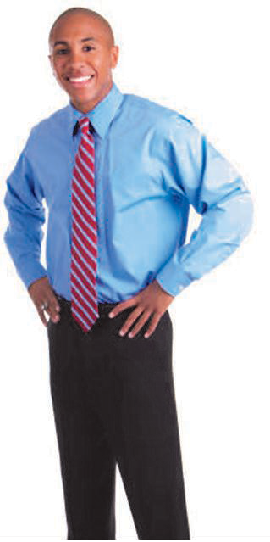

### I T’ S B E T T E R T O B E O V E R D R E S S E D

**T H AN U ND E R - DR E S S E D .**

This outfit is an excellent example of the variety of clothing options that a business casual workplace pro- vides. Tops such as button-downs, sweaters, turtle- necks, and blouses, for example, are suitable for the office. This woman paired a clean, white shirt with a nice sweater. Yes, this is a casual look, but, she is still presentable and professional. Following the standards of a business casual dress code, this option is not dis- tracting, offensive, or too casual - instead, it's perfectly practical for work.

This is a good business casual option for a man. This option still upholds a professional image, but is successful at being a more relaxed outfit without looking like everyday street wear. A dress shirt and tie still looks nice, for example, but a full suit isn't necessary in a business casual environment.



For women, a fitted suit jacket paired with a blouse is appropriate for a business casual workplace. This is a crisp, professional look, but still appears relaxed with a more casual vibe. This women shows the cor- rect use of jewelry in a business casual environ- ment, tastefully choosing a necklace that comple- ments her outfit without drawing too much attention.

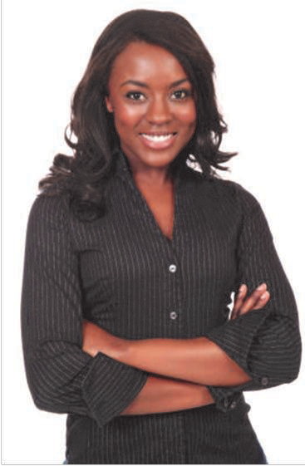

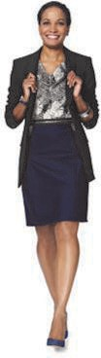

This is a basic look for a business casual workplace. A nice dress shirt can be worn without a tie, yet still looks professional and put together. Dress pants in a lighter color can also be another option for a casual environment. A conservative leather belt adds a nice finish to this basic business casual outfit for men.

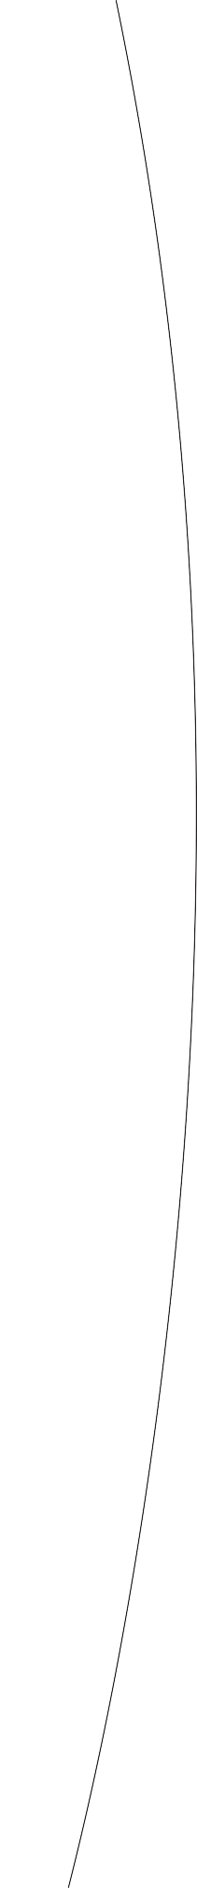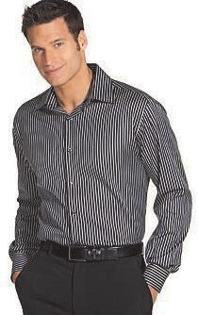

B u s i n e s s C a s u a l

F o ot w e a r

Conservative athletic or walking shoes, loafers, clogs, sneakers, boots, flats, dress heels, and leather deck-type shoes are acceptable. Wearing no stockings is ac- ceptable in warm weather. Flashy athletic shoes, thongs, flip-flops, slippers, and any shoe with an open toe are not

acceptable in the office.

B u s i n e s s C a s u a l A c c e s s o ri e s a n d J e w el ry

Accessories and jewelry should be worn in good taste, with limited visible body

piercings.

B u s i n e s s C a s u a l M a k e u p a n d F r a g r a n c e s

All products should be worn in good taste. Remember that some people are allergic to the chemicals in perfumes and makeup, so wear these

substances with restraint.

This employee looks great in her business casual outfit. Her shirt is pressed and fits well, without revealing her chest or stomach. With her sleeves cuffed, she maintains a casual look that's just right, and still professional. This business casual option is polished and comfortable, perfect for a business casual workplace.

# academic



A c a d e m i c C as u a l

F o ot w e a r

Conservative walking shoes, dress shoes, oxfords, loafers, boots, flats, dress heels, and backless shoes are acceptable for work. Women may wear mid-height heels that are attractive and professional, without being

too formal.

A c a d e m i c C as u a l A c c e s s o ri e s a n d J e w el ry

Accessories and jewelry should be flattering, but still professional. Leather accessories such as brief cases, portfolios, etc. are representative of the

academic casual look.

A c a d e m i c C as u a l M a k e u p a n d F r a g r a n c es

All products should be worn in good taste. Remember that some people are allergic to the chemicals in perfumes and makeup, so wear these

substances with restraint.

## casual

A n i n t r o d u c t i o n t o t h e A c a d e m i c C a s u a l d r e s s c o d e

Many of us have a general idea of what Business Casual and Business Formal means. But what is Academic Casual? Also called Smart Casual, the Academic Casual dress code includes a variety of options for men and women. Smart casual dress is a step up from business casual, but not as dressy as formal work attire. Smart casual implies that the individual has kicked his or her dressing up a notch from business casual in a smart and well-pulled-together look.

The smart casual look allows flexibility for personal taste in fashion and includes jackets, outfit-enhancing jewelry, dress pants, dress shirts, skirts, tailored sweaters, vests, ties, matching leather accessories, and leather pull on shoes and boots. Smart casual dressing is often adopted by those who want to look ready for their next promotion. Smart casual dress codes are followed in workplaces such as academia. It is also used at conferences where attendees may be casually dressed.

This man's outfit is an excellent representation of academic casual dressing. With a fitted vest that looks great, his outfit is well coordinated and appropriate for the office. His style and confidence shine through enhancing his professionalism. This is a great example of academic casual dressing.

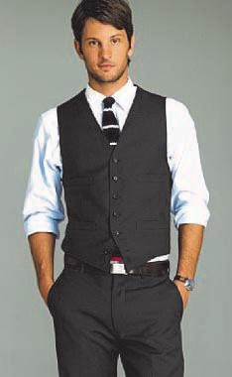

This man's semi-dressy sweater is another choice for men dressing academic casual at work. It's a great color, and when paired with well-fitting, dressy pants, it's a high quality and reliable look for an academic casual dress code.

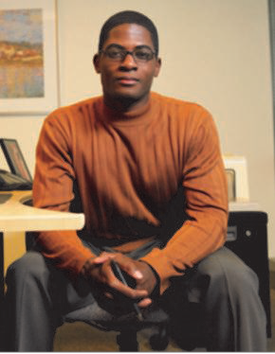

This woman's smart ensemble represents the flexibility people may have with their clothing in an academic casual dress code. For example, because she still looks professional and is dressed appropriately for the workplace, she can express her personal taste in a fashionable skirt and blouse combo paired with a structured jacket. Albeit this look may be too dressy for business casual and wouldn't work in a formal business environment, it's perfect for academic casual.

In this example, a brown jack- et and blouse are a great op- tion for women. This woman looks pulled together, well dressed, and professional. Shades of brown are a good option in academic casual dressing as opposed to the dark navies and blacks that characterize a formal dress code.

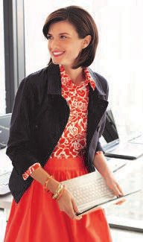



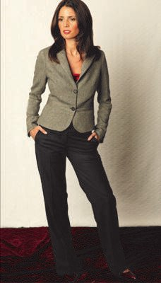

For women, the academic casual dress code can include nice slacks and a jacket, as seen in this example. The woman in this photo is wearing fashionable shoes that complement her outfit, another characteristic of academic casual dressing. She is well-dressed and looks pulled together, wearing clothes that are attractive and professional.

# academic

## professional

D R E S S F O R T H E J O B Y O U W A N T

### N O T T H E O N E Y O U H A V E .

A man’s business suit is a standard item for business professional attire. This suit looks sharp and projects a professional image that also looks great in the office.



Business suits don’t necessarily have to be black to look professional. You can express your personal style in choosing lighter colors, or a unique colored tie, for example, and still look appropriate for a formal business environment. However, it is important to remember that your clothes should not attract more attention than the work you’re doing. That said, it is still possible to express freedom and your own personality in your business formal op- tions and still look sharp. This is a great example of a business suit that isn’t your basic black suit, but is still an appropriate professional choice.

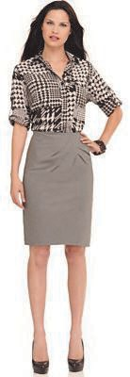

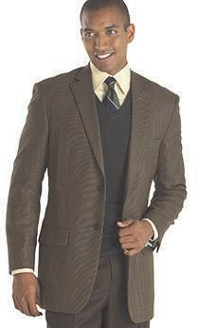

A c a d e m i c P r of e s s i o n a l

F o ot w e a r

Conservative walking shoes, dress shoes, oxfords, loafers, boots, flats, dress heels, and backless shoes are acceptable for work. Not wearing stockings or socks is inappropriate.

Athletic shoes, tennis shoes, thongs, flip-flops, slippers, and any casual shoe with an open toe are not acceptable

business formal footwear.

A c a d e m i c P r of e s s i o n a l A c c e s s o ri e s a n d J e w el ry

Tasteful, professional ties, scarves, belts, and jewelry are encouraged. Jewelry should be worn in good taste, with limited visible body

piercings.

A c a d e m i c P r of e s s i o n a l M a k e u p a n d F r a g r a n c e s

A professional appearance is encouraged and excessive makeup is unprofessional.

Remember that some people are allergic to the chemicals in perfumes and makeup, so wear these substances with

restraint.

Business formal dress for women can also include a nice, appropriate skirt and an equally formal blouse. When choosing a skirt, make sure that you can sit comfortably in public. Mini skirts, for example, or skirts that are short and tight are inappropriate. Blouses such as dress shirts, sweaters, button-down tops, and turtlenecks are acceptable as long as they look formal and professional. Casual shirts, such as t-shirts or tank tops, should be avoided. Also, blouses that are too low- cut or reveal your shoulders or back are not suitable for a work environment.

Women should also be mindful of their perfume. Overpowering perfume is not welcome in an office environment. Make-up should look more natural than attention-grabbing. Tasteful accessories, such as jewelry, scarves, or belts, are encouraged as long as they aren't over-the-top and still look professional.

A business suit is a great option for women, too. Women have the versatility of choosing either a pair of dress slacks, or a skirt, with a business suit jacket. As long as your slacks are formal dress pants and look nice, they are acceptable. Informal-type pants such as jeans, sweat pants, leggings, spandex, or shorts should be avoided. If you choose a skirt, it should have a comforta- ble fit that looks nice without being too-revealing. It's always safe to choose a skirt that hits the knee.

Here is a group of professionals who are still projecting a business formal appearance while employing the use of different colors and hues. Their clothes are perfectly formal for a business formal work environ- ment, and still attractive and nice- looking.



