I I I I





I 1



**2 0 2 4**



**SCHEDULE OF EVENTS**

## Saturday April 20, Scianna Hall

7:30 a.m. Registration Opens

8:30–9:45 a.m. Concurrent Panels Session I

10–11:15 a.m. Concurrent Panels Session II

11:30 a.m.–1 p.m. Lunch and Keynote Address, Trent Lott Center

Keynote Speaker: **HOPE HERRON**

Associate Director at the Millennium Challenge Corporation

1–2:30 p.m. Poster Presentations

2:30–3:30 p.m. Concurrent Panels Session III

3:45–4:45 p.m. Arts Showcase (Scianna Hall Auditorium)

5 p.m. Awards Ceremony (Scianna Hall Auditorium)

**ABOUT THE SYMPOSIUM AND ITS BENEFACTOR**

The Symposium began as an annual event in the Department of History under the direction of Dr. Phyllis Jestice. In 2011, USM alumnus Donald Drapeau began sponsoring a series of awards for student presenters, and the next year, the Symposium was expanded to include students from across campus. The Undergraduate Symposium on Research and Creative Activity has grown since that time to an event that includes a keynote address, art, dance, music, and theatre, as well as over 100 oral and poster presentations.

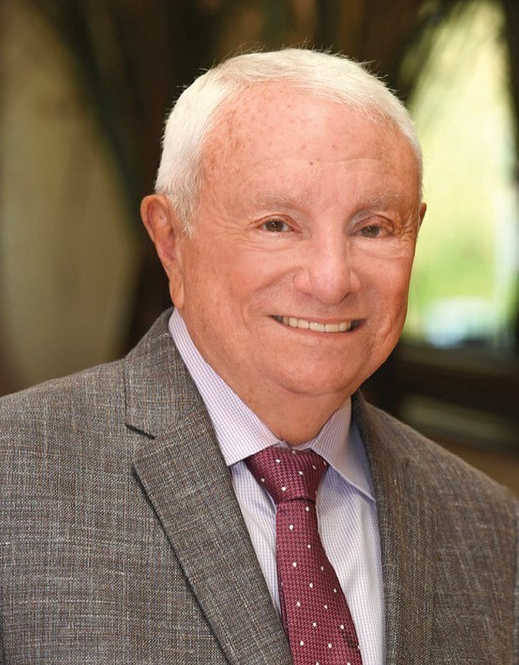

**DONALD DRAPEAU**, the Symposium’s generous benefactor, completed his Bachelor of Science in history at Southern Miss before going on to earn a master’s degree at the University of Pennsylvania.

He has enjoyed great success as founder and chief executive officer of the Man-Drapeau group of companies, which employs financial engineers and maintains offices on multiple continents. In the 1970s, he founded Drapeau and Co. and became a member of the Chicago Mercantile Exchange.

A Fulbright Fellow in Belgium and a Kress Fellow at the Harvard Business School, Mr. Drapeau is a passionate advocate of undergraduate students at Southern Miss and enjoys the opportunity to foster their sense of initiative, personal drive, and lifelong commitment to education and personal growth. His passion has led not only to his sponsorship of the prizes at the Symposium, but also to his support for the Drapeau Summer Research and Eagle SPUR Grants, which provide support for students’ research and creative projects. In 2016, Mr. Drapeau announced a gift to Southern Miss that resulted in the renaming of the Center for Undergraduate Research to the Drapeau Center for Undergraduate Research. In 2019, he was inducted into the Southern Miss Alumni Hall of Fame.

The Symposium could not exist without Mr. Drapeau, whose vision for valuing expanded opportunities for undergraduates has driven this enterprise and has shaped Southern Miss and the lives of hundreds of its students. We thank him for his commitment and his generosity.

**ABOUT OUR PLENARY SPEAKER**

**HOPE HERRON** is an associate director at the Millennium Challenge Corporation (MCC), a bilateral United States foreign aid agency, where she oversees the environmental and social performance of multi-million-dollar investments in support of MCC’s fight against global poverty. MCC provides time-limited grants (average size of

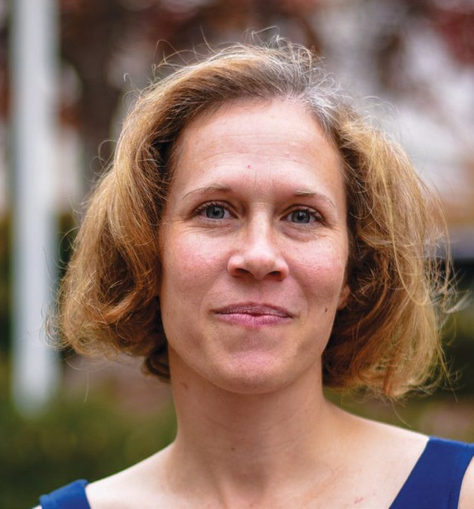

$340 million) to the world’s poorest countries that are committed to

just and democratic governance, economic freedom, and investing in their populations. MCC’s investments in core infrastructure and policy and institutional reforms are key interventions that are improving

the lives of nearly 270 million people across 46 countries and five continents. Ms. Herron helped to develop the MCC’s new Climate

Change Strategy and manages its climate change contract to implement the strategy. She is co-leading MCC’s work on the President’s Emergency Plan for Adaptation and Resilience (PREPARE) and represents the Agency on multiple National Security Council climate-related meetings and workstream efforts. Ms. Herron is a representative on the Agency’s Executive Diversity, Equity, Inclusion, and Accessibility (DEIA) Council, where she chairs the Recruitment Working Group to expand employment opportunities for underserved communities.

Prior to joining MCC, Ms. Herron led the resilient infrastructure practice for Tetra Tech, a global provider of consulting and engineering services. She provided strategic guidance to Tetra Tech’s corporate initiatives and project management and technical expertise to a wide range of international development agencies and multilateral clients. As the senior thought-leader for resilient infrastructure, Ms. Herron led many of the company’s innovative flagship climate change risk assessment and adaptation projects.

Ms. Herron received a B.A. degree in English with a minor in history from The University of Southern Mississippi, a Master of Natural Resource Studies degree from the University of Queensland, Australia, and a master’s degree in international communication from American University in Washington, D.C. She currently lives outside of Washington, D.C., with her wife, young son, and poorly trained dog. Ms. Herron is excited to return “home” to the USM campus. She proudly continued her family’s legacy of attending USM, which began with her grandfather’s attendance shortly after the school was founded. Her father was an All-American football player, her mother was a professor and director of the Center for Science and

Mathematics Education, and all three of her siblings attended USM. While at USM, Hope was a member of the Honors College, captain of the women’s soccer team, and vice president of the Student Athletic Council.

**ABOUT OUR HOSTS**

**DRAPEAU**

**CENTER FOR**

**UNDERGRADUATE RESEARCH**

**THE DRAPEAU CENTER FOR UNDERGRADUATE RESEARCH**

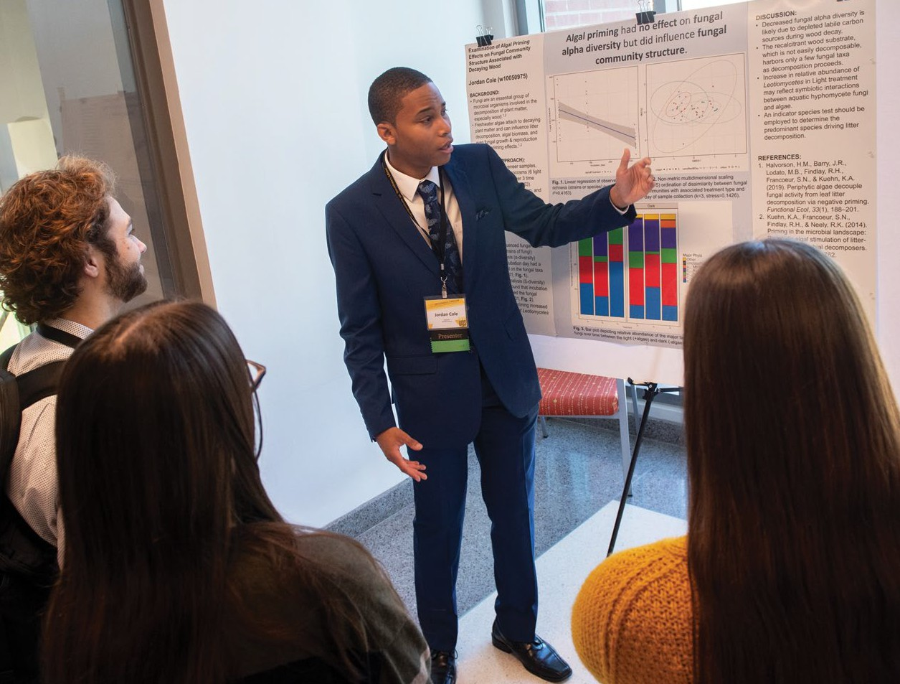

(DCUR) was established in October 2011, assuming the name of its benefactor, Donald Drapeau, in 2016. The mission of the center is to enhance the undergraduate experience by promoting and supporting student- faculty collaborations in research, creative projects, and scholarship.

The benefits of active participation in faculty-mentored research are myriad both to the student experience and the university community at large.

DCUR works with undergraduate

students to identify potential faculty mentors and sponsors competitive programs to assist students in their independent scholarship activities. These include the Eagle Scholars Program for Undergraduate Research (Eagle SPUR), which provides funds to support travel, to purchase equipment and supplies, and/or to be used as a stipend, and the Drapeau Summer Research Grants, which allow students to work full-time on their projects during the summer. You may learn more about these programs at [**usm.edu/undergraduate-research/drapeau-center.php**](http://usm.edu/undergraduate-research/drapeau-center.php).

**THE UNIVERSITY OF SOUTHERN MISSISSIPPI**

Honors College

The first honors college in Mississippi and one of the oldest in the nation, the Southern Miss

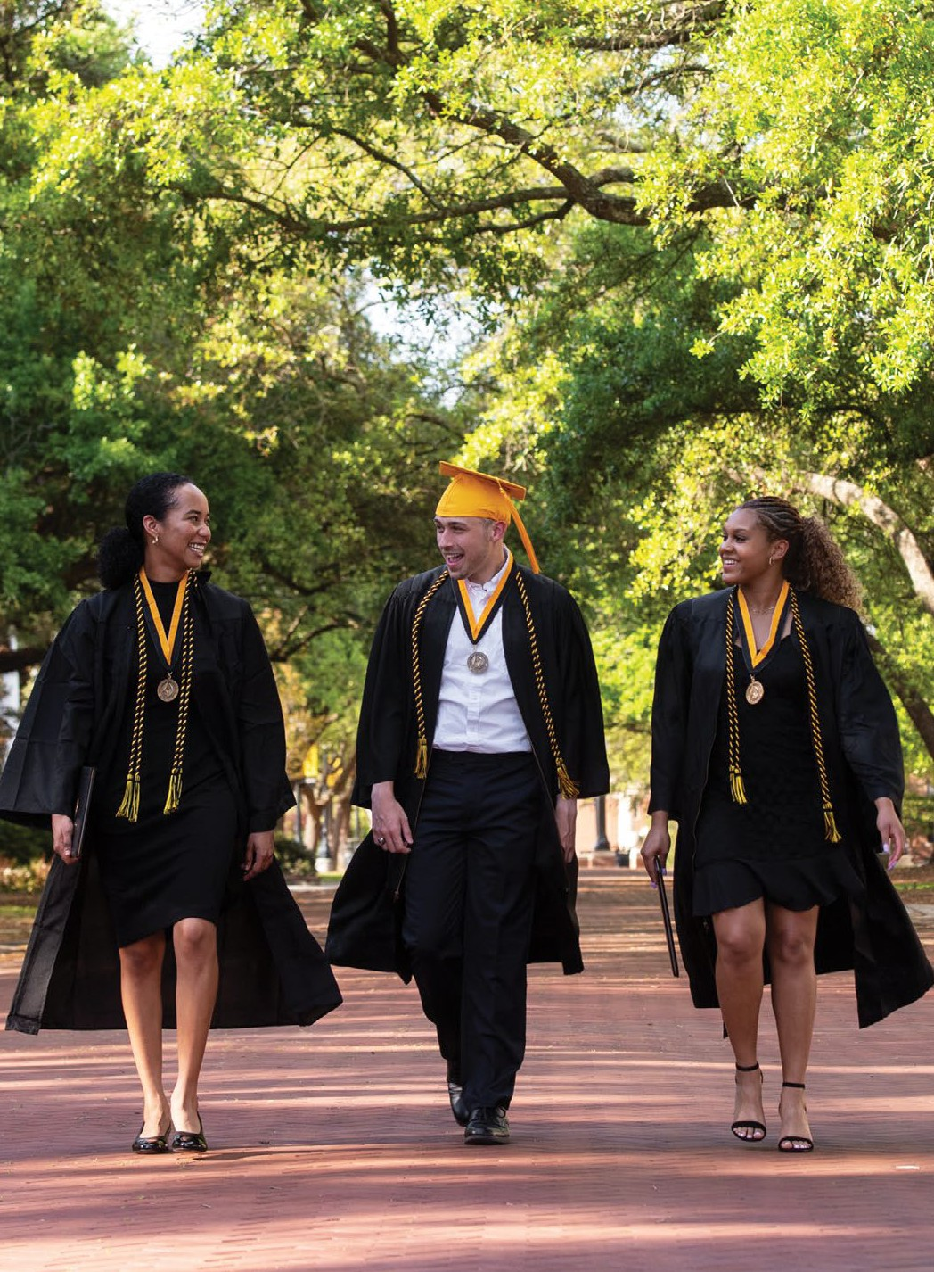

Honors College was founded in 1976 in an effort to offer enhanced educational experiences for high-achieving students. From its founding, the Honors College has required every student to undertake original research in the form of an Honors thesis, making the college a fitting host for the Undergraduate Symposium.

Through a supportive and challenging intellectual community and by valuing engaged and active learning, the college encourages its students to seize opportunities and boldly determine their own paths—both at the university and beyond.

Upon graduation, Honors Scholars have the independence and confidence to pursue their passions, the knowledge and tools with which to chart a fulfilling future course, and a lifelong commitment to using their capacities for the public good. For more information about the Honors College, visit [**usm.edu/hc**](http://usm.edu/hc)or contact us at [honors@usm.edu.](mailto:honors@usm.edu)

**THANK YOU!**

# THE 2024 SYMPOSIUM PLANNING COMMITTEE

This year’s Symposium was organized and developed through the hard work of a university-wide committee, which met throughout the 2023-24 academic year to put this event together. These faculty and staff members gave of their time and energy so that students and faculty could enjoy a successful Symposium. Thanks to all of them for their service!

**Allen Chen**, SCHOOL OF PERFORMING AND VISUAL ARTS

**Nicholas Ciraldo**, SCHOOL OF MUSIC

**Jeremy Deans**, SCHOOL OF BIOLOGICAL, ENVIRONMENTAL AND EARTH SCIENCES

**Brad Dufrene**, SCHOOL OF PSYCHOLOGY

**Sabine Heinhorst**, DRAPEAU CENTER FOR UNDERGRADUATE RESEARCH

**Jaide Hollingsworth**, HONORS COLLEGE

**Jared Hollingsworth**, SCHOOL OF MEDIA AND COMMUNICATION

**Joyce Inman**, HONORS COLLEGE

**Tegi Jenkins-Rimmer**, OFFICE OF THE VICE PRESIDENT FOR RESEARCH

**Kelly Lester**, SCHOOL OF PERFORMING AND VISUAL ARTS

**Joanne Tran**, SCHOOL OF MARKETING

**Rebecca Tuuri**, HONORS COLLEGE

**Alexandra Valint**, SCHOOL OF HUMANITIES

**Cyndi Wyles**, OFFICE OF THE VICE PRESIDENT FOR RESEARCH

# FACULTY JUDGES

We are grateful to the following Southern Miss faculty members for volunteering their time and energy to the UGS.

**Rabab Abdelfattah**, COMPUTER ENGINEERING

**THE SYMPOSIUM TAKES A GREAT DEAL OF PLANNING AND SUPPORT, AND WE WANT TO THANK ALL OF THOSE WHO HAVE CONTRIBUTED TO THE EVENT!**

**Mac Alford**, BIOLOGICAL SCIENCES

**Katie Angus**, FOREIGN LANGUAGES

**Diana Bernstein**, MARINE SCIENCE

**Katja Biswas**, PHYSICS

**Catharine Bomhold**, LIBRARY AND INFORMATION SCIENCE

**Kelsey Bonfils**, PSYCHOLOGY

**Alyson Brink**, PALEONTOLOGY

**Heather Broadhead**, POLYMER SCIENCE

**Quincy Brown**, HUMAN CAPITAL DEVELOPMENT

**Sean Buckelew,** HISTORY **Gordon Cannon**, BIOCHEMISTRY **Matthew Casey**, HISTORY

**Nora Charles**, PSYCHOLOGY

**Tristan Clemons**, POLYMER SCIENCE

**David Cochran**, GEOGRAPHY **Jennifer Courts**, VISUAL ARTS **Jeremy Deans**, GEOLOGY

**Kim de Mutsert**, MARINE SCIENCE **Matthew Donahue**, CHEMISTRY **Brad Dufrene**, PSYCHOLOGY

**Ian Dunkle**, PHILOSOPHY

**Jacob Esplin**, CHILD AND FAMILY SCIENCES

**Alex Flynt**, BIOLOGICAL SCIENCES

**Gabe Goldstein**, CONSTRUCTION AND DESIGN

**Helen Greene**, GEOGRAPHY

**Melissa Gutierrez**, BIOLOGICAL SCIENCES

**Timothy Gutmann**, PHILOSOPHY **Bridget Hayden**, ANTHROPOLOGY **Sabine Heinhorst**, BIOCHEMISTRY

**Karlie Herndon**, UNIVERSITY LIBRARIES

**Jeff Hirschy**, LIBRARY AND INFORMATION SCIENCE

**Mark Huff**, PSYCHOLOGY **Luis Iglesias**, ENGLISH **Joyce Inman**, ENGLISH **Joann Judge**, KINESIOLOGY

**Shahid Karim**, BIOLOGICAL SCIENCES

**Christy Kayser**, INTERDISCIPLINARY STUDIES

**John Kmiec**, HUMAN CAPITAL DEVELOPMENT

**Melissa Kossman**, REHABILITATION SCIENCES

**Deepak Kumar**, BIOLOGICAL SCIENCES

**Kelly Ferris Lester**, DANCE

**Ashley Marshall**, LIBRARY AND INFORMATION SCIENCE

**Katya Maslakowski**, HISTORY

**Marcus Michels**, VISUAL ARTS

**Gero Nootz**, OCEAN ENGINEERING

**Derek Patton**, POLYMER SCIENCE

**Nadine Phillips**, UNIVERSITY LIBRARIES

**Julie Pigza**, CHEMISTRY

**Maureen Ryan**, ENGLISH

**Bernd Schroeder**, MATHEMATICS

**Jeremy Scott**, PHYSICS

**Ahmed Sherif**, COMPUTER SCIENCE

**Ery Shin**, ENGLISH

**Diana Simpson**, UNIVERSITY LIBRARIES

**Kayla Stan**, GEOGRAPHY

**Alexis Stoner**, MARKETING

**Kevin Stott**, CHILD AND FAMILY SCIENCES

**Richard Swearengin**, FORENSIC SCIENCE

**Joanne Tran**, MARKETING

**Rebecca Tuuri**, HISTORY

**Kelly Vera**, BIOLOGICAL SCIENCES

**Wei Wang**, MARKETING

**Zhifu Xie**, MATHEMATICS

**Gallayanee Yaoyuneyong**, MARKETING

**Sharon Young**, SOCIOLOGY

**Tisha Zelner**, UNIVERSITY LIBRARIES

**Fan Zhang**, CONSTRUCTION AND DESIGN

# OUR CAMPUS SPONSORS

We would like to extend a special thank you to the College of Business and Economic Development for opening the doors of Scianna Hall to the Symposium, and to these sponsors for their generous support.

Vice President for Research Vice President for Student Affairs

and Enrollment Management College of Arts and Sciences

College of Business and Economic Development College of Education and Human Sciences

College of Nursing and Health Professions Graduate School

University Libraries Southern Miss Alumni Association

Southern Miss Athletics

We’d like to extend a special thank you to these donors for their kind support of our student scholars.





Best Presentation on a Biomedical Topic Loan of easels and boards

Best Community-Engaged Research or Creative Activity

**THANK YOU**



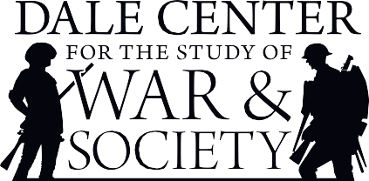

The Jack Lucas Award Arts Showcase Awards

**THE SOUTHERN MISS WOMEN’S AND GENDER STUDIES PROGRAM**

The Women’s and Gender Studies Prize

**THE SYMPOSIUM TAKES A GREAT DEAL OF PLANNING AND SUPPORT, AND WE WANT TO THANK ALL THOSE WHO HAVE CONTRIBUTED TO THE EVENT!**

# OUR COMMUNITY SPONSORS

Please help us thank our local sponsors by letting them know that Hattiesburg appreciates their support of student achievement at Southern Miss!





















## SPECIAL THANKS

to American Graphics for their especially generous support!



**SCIANNA HALL**

**ENTRANCES**

**Stairwell**

**Stairwell**

**FIRST FLOOR**

**1015**

**Stairwell**

**RESTROOMS**

**to**

**2n oor**

**RESTROOMS**

**d Fl**

**LOUNGE AREA**

**Snacks and Beverages**

**SOUTH HALLWAY**

**NORTH HALLWAY**

**REGISTRATION**

**FRONT STEPS MAIN ENTRANCE**

**1046**

**AUDITORIUM**

**Arts Showcase and**

**Awards Ceremony**

**1008**

**1040**

**Elevators**

**1014**

**Stairwell**

**SECOND FLOOR**

**Stairwell to**

**1st Floor**

**SOUTH HALLWAY**

**NORTH HALLWAY**

**CENTRAL HALLWAY**

**AUDITORIUM BALCONY**

**Elevators**

**RESTROOMS**

**2009**

**2004**

**Stairwell**

**2005**

**SCHEDULE OF SESSIONS**

**SATURDAY, APRIL 20**

# 8:30-9:45 A.M. CONCURRENT PANELS SESSION I

**SCI 1008 A WOMAN’S PLACE IN A CHANGING WORLD A**

**MODERATOR: KATHRYN MCKENZIE, SCHOOL OF HUMANITIES**

Hand-Holders of Tipu, Belize

**REAGAN STECKBECK, ANTHROPOLOGY**

A “Revolutionary” Portrait: A Lesser-Known Portrait’s Place in the Struggle for Women’s Equality in France During the French Revolution

**MORGAN MYRES, ART, WORLD LANGUAGES (SPANISH)**

The Unequal Marriage: Women and Status in 19th-Century Russia

**KAYLEE SELLE, ART**

The Azalea Trail Maids: White Women’s Contributions to the Lost Cause in Mobile, Alabama

**EMMA RAWLS, HISTORY, ENGLISH**

**SCI 1014 TRANSLATION, TRANSFORMATION, AND LIBERATION IN TEXT, ON STAGE, AND IN FILM B**

**MODERATOR: FAITH NNENNA OMULU, SCHOOL OF HUMANITIES**

Not If It’s You: A Historiographical Evaluation of Common Problems in Translation Methodology and Their Solutions Through the Lens of Euripides’ *Orestes*

**KALEIGH LANDERS, WORLD LANGUAGES (FRENCH)**

Becoming the Mask: Performance as Parasitism in Ben Jonson’s *Volpone*

**JENNA MCCLAIN, ENGLISH**

*A Raisin in the Sun* Book and Film Comparison

**MAYA WOOD, ENGLISH**

Liberation in *Dune*

**AMIN WHITMORE JR., CRIMINAL JUSTICE**

**SCI 1015 CHEMICAL SYNTHESIS C**

**MODERATOR: LEAH CASE, SCHOOL OF MATHEMATICS AND NATURAL SCIENCES**

Synthesis of Piperidines via the Intramolecular Prins Cyclization of N-Sulfonyl Alpha-Aminoacetals

**DAMIEN COOPER, CHEMISTRY (ACS-CERTIFIED CHEMISTRY)**

Addition of Masked Acyl Cyanides to Substituted Benzylic Acetimidates

**MACKENZIE PIERCE, CHEMISTRY (BIOCHEMISTRY)**

Synthesis of Substituted Pyrroles from N-Sulfonyl Enamines

**DREW ROWELL, CHEMISTRY (ACS-CERTIFIED CHEMISTRY)**

N-Methylpyridinium as a Novel Charged Acidifying Group for Squaramide Organocatalysts

**AIDEN LEISE, CHEMISTRY (ACS-CERTIFIED CHEMISTRY)**

**SCI 1040 ART AS PRACTICE: REFLECTIONS ON PURSUING THEATRE AND DANCE PROJECTS D**

**MODERATOR: AMELIA MOREHEAD, SCHOOL OF PSYCHOLOGY**

And So, My Heart Became a Void—A Dance Film

**GRACE DUGAS, DANCE (PERFORMANCE AND CHOREOGRAPHY)**

An Opportunity for the Dance Educator

**EMMA DUNAWAY, DANCE (DANCE EDUCATION)**

Undergraduate Devised Theatre Showcase

**SETH RODIVICH, THEATRE (ACTING)**

#bookedandblessed: A Theatrical Job Search

**GEORGIA LEMING, THEATRE (GENERAL THEATRE)**

**SCI 2004 HOW GEN Z NAVIGATES MEDIA, IDENTITY, AND BELONGING E**

**MODERATOR: ALEXA TRINGALI, SCHOOL OF PSYCHOLOGY**

The Truth from Her Red Lips?: Taylor Swift and the Emerging Phenomenon of Celebrity Political Influence

**KYLIE PRICE, THEATRE (ACTING)**

“And You’re Watching Disney Channel!”: Disney, Gender, and Gen Z

**EMILY SMITH, HISTORY, SOCIOLOGY, PEARL RIVER COMMUNITY COLLEGE**

Groomer Discourse: A Transgender-Sensitive Critical Discourse Analysis of Queerphobic Hate Speech on Twitter

**WILLIAM EVANS, COMPUTER SCIENCE**

The Beautiful, the Messy, and the Sad

**EZABELLE JANSSEN, ENGLISH**

**SCI 2005 MATHEMATICAL SOLUTIONS F**

**MODERATOR: MEAGAN STANLEY, SCHOOL OF MATHEMATICS AND NATURAL SCIENCES**

Integral Sequences of Legendre Polynomials

**LUKE FONTAN, MATHEMATICS**

The Numerical Method for Finding All the Zeros of a Function f(x) on an Interval [a,b]

**FRANISSA SIMON, MATHEMATICS**

Component-Wise Backward Differentiation Formulas for Stiff Systems of Ordinary Differential Equations

**ANZHELIKA VASILYEVA, MATHEMATICS**

Exact Calculation of the Probability of Li-7(p, α)He-4 Reactions in a Thick LiF-Target

**MAXIMILIAN ALBERTH, PHYSICS**

**SCI 2009 TESTING DEMOCRACY’S LIMITS G**

**MODERATOR: AUGUST JOSEPH NAMUTH, SCHOOL OF PSYCHOLOGY**

Jury Duty and Justice: An Analysis of the Shortcomings of Jury Duty in the United States

**MARLENA TESTON, LEGAL STUDIES (PARALEGAL), PHILOSOPHY**

The Fragility-Necessity Correlation in Democratic Systems

**CAM FARVIN, PHILOSOPHY, POLITICAL SCIENCE**

Equal Conditions, Unequal Outcomes

**TERESA DIGEROLAMO, POLITICAL SCIENCE, WORLD LANGUAGES (SPANISH)**

# 10-11:15 A.M. CONCURRENT PANELS SESSION II

**SCI 1008 CIVIL RIGHTS, POLITICS, AND MEMORY IN MISSISSIPPI H**

**MODERATOR: CYNTHIA MYLES, SCHOOL OF HUMANITIES**

“Where Is Bud Strong?”: The Lost Martyr of the Mississippi Civil Rights Movement

**MICAH LYNN, HISTORY**

Freedom Summer: McCain Scared Red

**JOSEPH REOSTI, HISTORY, POLITICAL SCIENCE (PRE-LAW)**

Omissions Are Not Amends: Evelyn Gandy’s Racial Politics and Legacy, 1920-2008

**KYLE SIMPSON, HISTORY**

A History of Mississippi Segregation Academies and How They Serve as Agents of Socialization in Students’ Political Affiliations

**HANNA ALLEN, POLITICAL SCIENCE**

**SCI 1014 THE IMPORTANCE OF INCLUSION IN EDUCATION I**

**MODERATOR: SABA SHAHID, SCHOOL OF PSYCHOLOGY**

The Case for Educational Equity in Mississippi: An Analysis of Mississippi’s Social Emotional Learning Standards from a Critical Lens

**MADISYN KILLOUGH, ELEMENTARY EDUCATION**

An Analytical Study on the Role of Pedagogy on Racial Achievement Gaps in America

**ALY GONZALEZ, SOCIOLOGY, POLITICAL SCIENCE**

Inclusive Policies, Diverse Perspectives: Affirmative Action and the Model Minority Among University Students

**JANNIE NGUYEN, POLITICAL SCIENCE**

Sense of Belonging, the Institution, and the University Writing Center

**JAYLIN JONES, ENGLISH**

**SCI 1015 EXPLORING MOLECULAR MECHANISMS IN BIOLOGY J**

**MODERATOR: ALEX MELVILLE, SCHOOL OF PSYCHOLOGY**

The Impacts of PFAS Exposure on Expression of PPARα and PPARγ in Larval Sheepshead Minnows

**SOPHIE VORIS, BIOLOGICAL SCIENCES**

Bioinformatic Analysis of the NF-κB Pathway in Mouse Trophoblast Stem Cells in Response to TNFɑ

**YESEUL BAE, BIOLOGICAL SCIENCES (BIOMEDICAL SCIENCES)**

Redox Based Modulation of Biomolecular Condensates by Disulfide Bond Cross-Links in Designer Peptides

**LANDON LEE, CHEMISTRY (BIOCHEMISTRY)**

**SCI 1040 OPERATIONAL EFFICIENCY, CONSUMER BEHAVIOR, AND SOCIAL MEDIA IN BUSINESS AND NONPROFIT ORGANIZATIONS**

**K**

**MODERATOR: AMANDA WALSH, SCHOOL OF MEDIA AND COMMUNICATION**

Altaworx, LLC.: A Comparative Analysis of Liquidity, Profitability, Efficiency, and Debt Management

**ANDY WELCH, FINANCE**

Bots, Branding, and Behavioral Intentions

**HAEDEN OVERBY, HOSPITALITY AND TOURISM MANAGEMENT**

Film Tourist Perceptions of Congruity, Attachment, and Intentions Modeling

**PATRICK TYSON, ANTHROPOLOGY, SOCIOLOGY, WORLD LANGUAGES (SPANISH)**

Exploring Nonprofit Organization Directors’ Strategies in Social Media Involvement with Consumers - A Qualitative Approach

**GREYSON SWARTZFAGER, BUSINESS ADMINISTRATION (ENTREPRENEURSHIP)**

**SCI 2004 EXTANT AND EXTINCT INVERTEBRATES L**

**MODERATOR: JAMION BURNEY, SCHOOL OF PSYCHOLOGY**

*Culex antillummagnorum*: Recording a Novel Mode of Oviposition in the Culex Mosquito Genus

**LIZ WYNNE, BIOLOGICAL SCIENCES**

Contrasting the Distribution of Aquatic Macroinvertebrates Above and Below a Sill in the Lower Bouie River, Mississippi

**NATALIE SANTIAGO, MARINE BIOLOGY**

Effects of Dissolved Oxygen and pH on Eastern Oyster (*Crassostrea virginica*) Growth

**KARINA LEDEZMA, MARINE SCIENCE**

The Taxonomy and Survivorship of Indigenous Ostracod Fauna After the Cretaceous/Paleogene Extinction Event

**HELENA JIMENEZ ELDER, GEOLOGY**

**SCI 2005 COMMUNICATION AND DEVICE ENGINEERING M**

**MODERATOR: BENJAMIN GOUDY, SCHOOL OF HEALTH PROFESSIONS**

Modular and Interactive Button System for Visually Impaired Children

**RANNI MIDDLETON, POLYMER SCIENCE AND ENGINEERING**

Proof of Concept of Coastal Autonomous Profiling Float for Ocean Data Collection

**COREY CHAMBLEE, OCEAN ENGINEERING**

Establishing a LoRaWAN Gateway at The University of Southern Mississippi

**TREVOR WHALEN, OCEAN ENGINEERING**

**SCI 2009 A NEW PERSPECTIVE: VISUAL ART AS DESIGN, PROFESSION, OR MNEMONIC DEVICE N**

**MODERATOR: SHIZA SHAHID, SCHOOL OF PSYCHOLOGY**

How Can Fashion Be Used as a Design Tool Within Painting?

**CALAIS BATES, ART**

Networking in Norman

**DONISHA EDWARDS, ART (SCULPTURE)**

Drawing Both Helps and Harms Memory Depending on the Context

**HALLIE CULPEPPER, PSYCHOLOGY**

# 1-2:30 P.M. POSTER PRESENTATIONS

**SCI FIRST FLOOR, NORTH HALLWAY**

1. Uncovering the Role of *Amblyomma americanum* tRNA Synthetases in Hematophagy and *Ehrlichia* Infection

**ANZA ALI, BIOLOGICAL SCIENCES (BIOMEDICAL SCIENCES)**

1. Landscapes and Morals in Jane Austen’s *Mansfield Park*

**MONTANAH MIDDLETON, ENGLISH (LICENSURE)**

1. Correlation of Scales from Gulf Menhaden (*Brevoorita patronus*)

**MICHAEL ZARSKE, MARINE BIOLOGY**

1. Emotion and Ethics: Exploring Emotional Intelligence and Acquisition of Ethical Values in Undergraduate Nursing Students

**KARLEE WALDEN, NURSING**

1. The Effect of Text Manipulation on Reading Comprehension Among Children with Attention-Deficit/Hyperactivity Disorder Using the Bionic Reading Method

**SHELLEY BENTZ, PSYCHOLOGY**

1. Synthesis and Characterization of Bioactive Supramolecular Polymers to Promote Skin Regeneration

**JESSICA SHRESTHA, POLYMER SCIENCE AND ENGINEERING**

1. How Does Fear of AI Impact the Current College Student’s Career Decisions?

**JOSEPH DUNLAP, NURSING**

1. Sing It Loud and Proud! But Don’t Expect Singing to Produce a Large Benefit to Memory

**ELIZE JACKSON, PSYCHOLOGY COLIN BRUFF, PSYCHOLOGY**

**AIDAN BROWN, PSYCHOLOGY**

1. My Undergraduate Research Odyssey: Investigating the Time-Dependent Gene Expression of Phospholipase A2 in Tick Salivary Glands

**FATIMA KARIM, BIOLOGICAL SCIENCES (BIOMEDICAL SCIENCES)**

### SCI FIRST FLOOR, SOUTH HALLWAY

1. Jed’s Multimedia Alternate Reality Game Franchise

**JED GUIN, ENGLISH (LICENSURE)**

1. Examining the Relationship Between Familial Affective Response and Child Externalizing Behaviors: The Role of Household Chaos

**AKIYAH BRANDON, PSYCHOLOGY**

1. Erosion in Coastal Louisiana and Mississippi: A Look into Erosion and Accretion Rates Through GIS

**BAILEY LINER, BIOLOGICAL SCIENCES (CONSERVATION BIOLOGY)**

1. Musselwhite: A Case Study in the Development of Modern Legend in the American South

**ELLA LAUDERDALE, LIBRARY AND INFORMATION SCIENCE**

1. Inhibiting Bacterial Growth Through Electrostatic Interaction

**LENA BLAKE, POLYMER SCIENCE AND ENGINEERING**

1. The Effectiveness of Mentoring for Juvenile Youth

**OLIVIA DAMPIER, PSYCHOLOGY**

1. WATTS Next: The Future of the Tokamak Reactor

**SAHIL AJMERA, CHEMICAL ENGINEERING, PEARL RIVER COMMUNITY COLLEGE**

1. Spray Delivery of Supramolecular Polymer Biomaterials

**LORIA DIMARTINO, POLYMER SCIENCE AND ENGINEERING**

1. Knighted Pawn Tours

**MORGAN WILSON, MATHEMATICS, COMPUTER SCIENCE**

### SCI SECOND FLOOR, NORTH HALLWAY

1. Drone Mapping Application for Agriculture

**NATHANIEL PARDEE, COMPUTER SCIENCE (APPLIED COMPUTER SCIENCE) TICAURIS STOKES, COMPUTER SCIENCE (APPLIED COMPUTER SCIENCE)**

1. Is Disturbance Stridulation in the Passalid Beetle *Odontotaenius disjunctus* a Form of Social Communication?

**HALEY SCHONEKAS, BIOLOGICAL SCIENCES (CONSERVATION BIOLOGY)**

1. Technical Difficulties: An Investigation of Problematic Social Media Usage and Well-Being of Emerging Adults

**SARAH SWAN, NURSING**

1. Upcycling Woven Polypropylene Textiles to Carbon-Based Joule Heaters

**PARKER FRAME, POLYMER SCIENCE AND ENGINEERING**

1. Individual PBSA Related to Reduced Pregaming in College Students

**SOPHIE DENTON, PSYCHOLOGY**

1. Impact of Differing Levels of Dissolved Oxygen on Oyster Biomass and Survival

**JAIDYN ALLEN, MARINE BIOLOGY**

1. NCAA D1 Student-Athletes’ Understandings of and Attitudes Toward Mental Performance Services

**ALLIE RUDISILL, KINESIOLOGY (EXERCISE SCIENCE)**

1. Assessment of a Muscadine (*Vitis rotundifolia*) Grape Mapping Population for Tolerance to Black Rot Disease Pathogen,

*Guignardia bidwellii*

**TABASSUM SIDDIQUE, BIOLOGICAL SCIENCES (MICROBIOLOGY)**

1. How Does Exposure to Juvenile Offenders Affect Assumptions and Biases?

**NEVAEH GRIMME, PSYCHOLOGY**

### SCI SECOND FLOOR, CENTRAL HALLWAY

1. Exploring How Microclimates Shape the Relationship Between Body Size and Thermal Tolerance in a Tropical Ant Community

**CAROLINE MARLEY, BIOLOGICAL SCIENCES**

1. Exploring the Collegiate Choral Musician’s Values Within Ensemble Performances

**KAELYN HUNTER, MUSIC EDUCATION (CHORAL LICENSURE)**

1. Impact of Training Volume on Female Athlete Triad Risk Score for Female Collegiate Track and Field Athletes

**SARAH PARNELL, KINESIOLOGY (EXERCISE SCIENCE)**

1. Adaptive Security Systems: Revolutionizing Web Application Protection

**SANDESH BHATTARAI, COMPUTER SCIENCE ABRAHAM ABEBE, COMPUTER SCIENCE**

1. Can Decision-Making Affect Your Well-Being

**EMILY JONES, PSYCHOLOGY**

1. Elucidation of the Effect of Polymer Architecture on Targeting Ligand Presentation in Nucleic Acid Delivery Vehicles

**ANTHONY RADKA, POLYMER SCIENCE AND ENGINEERING**

1. Juveniles’ Engagement in Mentoring Programs: Do Presentation Topics and Adult Charges Impact Engagement?

**GABBY MCCROSKEY, PSYCHOLOGY**

1. Quantifying School-Based Physical Activity Using a Clearinghouse Model: Physical Activity Clearinghouse in Education (P.A.C.E.)

**REAGAN DANIELL, KINESIOLOGY (EXERCISE SCIENCE)**

1. The Effect of the Black Ink Red Ink Testing Method on Anxiety Levels, Test Performance, and Note-Taking Behavior Among College Students

**PEYTON MURPHY, PSYCHOLOGY**

1. Opportunities in Low Temperature Photoiniferter RAFT Polymerization

**MAC MCCORMICK, POLYMER SCIENCE AND ENGINEERING, CHEMISTRY (ACS-CERTIFIED CHEMISTRY)**

1. Quality of Life in People With and Without a Sexual or Gender Minority Identity with Disabilities

**B. TWILBECK, PSYCHOLOGY, SOCIOLOGY**

1. Division of Labor in Flight Behavior of Stingless Bee (*Tetragonisca angustula*) Soldiers

**JOSEPH SERIO, BIOLOGICAL SCIENCES**

1. A Musician’s Greatest Sense: The Impact of Hazardous Noise Levels on the Hearing Mechanism of Marching Band Students

**MAGGIE WESTBROOK, SPEECH PATHOLOGY AND AUDIOLOGY**

### SCI SECOND FLOOR, SOUTH HALLWAY

1. The Influence of Social Media on Public Opinion of the Ukraine Conflict

**MARINA GOUPALOVA, CHEMISTRY (ACS-CERTIFIED CHEMISTRY)**

1. Project Juveniles’ Right to Decide: A Systemic Analysis of Juvenile Plea Research

**KAYCE ALLEN, CRIMINAL JUSTICE (JUVENILE JUSTICE)**

1. Designing a Filter for the Preservation of Cellulose Acetate Films

**JACOB CREEL, POLYMER SCIENCE AND ENGINEERING**

**BRECKENRIDGE JONES, POLYMER SCIENCE AND ENGINEERING REAGAN BROWN, POLYMER SCIENCE AND ENGINEERING**

1. Seated Versus Standing Blood Pressure as an Assessment in Autonomic Dysfunction in Metabolic Syndrome

**BRAEDON WALKER, KINESIOLOGY (EXERCISE SCIENCE)**

1. Consumer Activism: An In-Depth Examination of Motivations and Practices Among College Students

**MARCUS KIRKLAND, MARKETING**

1. Design of Electrical Heating Devices for Decarbonized Synthesis and Processing

**JESSIE GILMORE, POLYMER SCIENCE AND ENGINEERING**

1. Anxiety, Loneliness, and Quality of Life Among Sexual and Gender Minorities: The Effect of Community Type

**BRADEN WAUGH, PSYCHOLOGY**

1. Implementing a Modular and Interactive System for Visually Impaired Children

**JESSE JENKINS, POLYMER SCIENCE AND ENGINEERING DYLAN GRIFFIN, POLYMER SCIENCE AND ENGINEERING**

1. Familiarity and Recollective Curiosity: Is There a Role of Agency?

**HILLARY ROMOSER, PSYCHOLOGY**

1. How to Explain the Convergence Analysis of Allen-Manandhar’s Method to Beginners?

**REBECCA SCARIANO, MATHEMATICS**

# 2:30-3:30 P.M. CONCURRENT PANELS SESSION III

### SCI 1008 VIOLENCE, GORE, AND MONSTERS AS REFLECTIVE OF THE HUMAN CONDITION O

**MODERATOR: ANDREW BLEDSOE, SCHOOL OF PERFORMING AND VISUAL ARTS**

Providing a Service

**OLIVIA PIERCE, ENGLISH**

Savagery, Status, and Soutine: the Exorcism of Trauma via Works of Gore

**KEVIN KLAUK, ART**

Rites of Shrouded Waves and Dragon Flame: The Role of Water and Fire in Purvis’ *Beowulf*

**KATHERINE PURVIS, ENGLISH**

**SCI 1014 ADVANCING BETTER MENTAL HEALTH OUTCOMES P**

**MODERATOR: NIKKIE BAILEY, SCHOOL OF PSYCHOLOGY**

Gender, Body Shame, and Sexual Anxiety: A Mediational Model Among College Students

**ALLISON HANBY, CHILD AND FAMILY SCIENCES**

Examining Healthcare Professionals’ Perceptions and Utilization of Recreational Therapy for Mental Health Care

**CHRYSTEN BROOME, RECREATION (THERAPEUTIC RECREATION)**

The Angry Black Woman Stereotype: Investigating Associations with Mental Health Outcomes and Treatment- Seeking Behaviors in Black Women

**AISJAH HICKS, PSYCHOLOGY**

**SCI 1015 THE IMPACT OF GEOGRAPHY IN MISSISSIPPI IN THE 19TH CENTURY Q**

**MODERATOR: LIZ LAMKIN, SCHOOL OF PSYCHOLOGY**

Desperate Times: Salt and Slave Labor During the Civil War

**DIPPER NOBLES, HISTORY**

The Road to Secession: Attitudes About Secession in Mississippi Before and During the Civil War Era

**QUINTEN WILLIAMS, COMPUTER SCIENCE**

Port of Pascagoula: An Environmental History to 1900

**WILLIAM PITTMAN, INTERDISCIPLINARY STUDIES**

**SCI 1040 IMPROVING LAW ENFORCEMENT PRACTICES, PAST AND PRESENT R**

**MODERATOR: ZACH BUCKNER, SCHOOL OF PSYCHOLOGY**

Applying Pressure: How Robert Kennedy Forced J. Edgar Hoover to investigate the Mafia

**KRIS MICHAELSON, HISTORY**

Adults Matter, Too: An Examination of State Adult Missing Persons Policies and Procedures to Implement a Best Practices Handbook

**HUNTER SMITH, FORENSICS (ANTHROPOLOGY)**

Assessing the Accuracy and Precision of Crime Scene Measurements Obtained from iPhone LiDAR Scans

**JASON ANG, FORENSICS (BIOLOGICAL SCIENCES)**

**SCI 1046 MODELING BIOLOGICAL PHENOMENA S**

**MODERATOR: CHEYENNE BRADY, SCHOOL OF LIBRARY AND INFORMATION SCIENCE**

Differential Equation Modeling the COVID-19 Pandemic Using Simple SIRF and Modified SIRF-V Systems on Select U.S. States

**JACOB GARDNER, MATHEMATICS**

Modeling the Open Probability of Ion Channels Using Deep Neural Networks

**ABEL GURUNG, MATHEMATICS**

**SCI 2004 THE EFFECTS OF REGULATION AND PUBLIC POLICY ON GUN VIOLENCE, CLIMATE CHANGE, AND BITCOIN POLICIES**

**T**

**MODERATOR: ABEL UGWU, SCHOOL OF HUMANITIES**

Climate Change Consensus and U.S. Senatorial Speech

**BRANDON DERR, POLITICAL SCIENCE**

Unrestricted Concealed Carry and Its Implications for School Shooting Incidents in the United States

**BREANNA MASTERSON, APPLIED ECONOMICS, MATHEMATICS**

How Bitcoin Price Reacts to United States Government Public Legislation Releases

**WALTER JOHNSON, ACCOUNTING, FINANCE**

**SCI 2005 CYBERSECURITY AND PRIVACY U**

**MODERATOR: KHADIZA AKTER, SCHOOL OF PSYCHOLOGY**

Advancing Ransomware Detection and Classification: Utilizing Neural Networks and Extensive Data Analysis

**SAJIM AHMED, COMPUTER SCIENCE**

Multilayer Perceptrons for Efficient and Accurate Zero-Day Attack Detection

**ASHIM DAHAL, COMPUTER SCIENCE PRABIN BAJGAI, COMPUTER SCIENCE**

Hardware-Acceleration Based Privacy-Aware Authentication Scheme for Internet of Vehicles

**KAYLA WHITE, COMPUTER ENGINEERING**

**RABEEA FATIMA, COMPUTER ENGINEERING**

**SCI 2009 NEW CHEMICALS AND MATERIALS AND THEIR APPLICATIONS V**

**MODERATOR: MIKAELA SADRI, SCHOOL OF POLYMER SCIENCE AND ENGINEERING**

Suppressing Reactive Oxygen Species via Application of Antioxidant Supramolecular Polymers

**ZACCHAEUS WALLACE, POLYMER SCIENCE AND ENGINEERING**

Development of Coumarin-Enamine Based Fluorescent Sensors for Selective Detection of Silver and Heavy Metal Ions

**JADEN SIERRA, CHEMISTRY (ACS-CERTIFIED CHEMISTRY)**

Total Synthesis of Halofuginone Derivatives as Tick Inhibitors

**OUSSAMA ERRIDA, CHEMISTRY (ACS-CERTIFIED CHEMISTRY)**

# 3:45-4:45 P.M. CREATIVE AND PERFORMING ARTS SHOWCASE

### SCIANNA HALL AUDITORIUM

Join us for a celebration of creative activity by undergraduates at Southern Miss.

Q&A and Recognition of Visual Artists

*The Spiral*

**BY MADALIN COSTELLA, ART (SCULPTURE)**

*Stages of Grief*

**BY KAYLA (ASHER) BEELES, ART (SCULPTURE)**

*Mississippi Magnolia Tea Set*

**BY ELLA LAUDERDALE,**

**LIBRARY AND INFORMATION SCIENCE**

*The Seagull or How to Design It*

**BY LAYDEN LACY,**

**THEATRE (COSTUME DESIGN)**

*And So, My Heart Became a Void—A Dance Film*

**CHOREOGRAPHED AND PRODUCED BY GRACE DUGAS, DANCE (PERFORMANCE AND CHOREOGRAPHY) DIRECTED AND EDITED BY SOPHIE CARLBERG**

**PERFORMED BY TATIANA JOHNSON AND GRACE DUGAS MUSIC BY URSINE VULPINE AND ANNACA**

*The Emotion Experiment*

**WRITTEN AND READ BY LAURA RENFROE, ENGLISH**

*Procastinera*

**PRODUCED AND DIRECTED BY AMANDA MYRICK, MEDIA AND ENTERTAINMENT ARTS (VIDEO ARTS) CO-PRODUCED BY ROMANIA HARRY**

**PERFORMED BY NANCY BYERS, AMANDA MYRICK, CLINT MYRICK, AND FARRAH WILD**

*Windows to the Soul*

**CHOREOGRAPHED BY SEANA RAINS, DANCE (DANCE EDUCATION)**

**PERFORMED BY CAITLYN DIAMOND, ANGELINA JONES, SEANA RAINS, AND PRESLEY THAMES MUSIC BY THE ROLLING STONES**

*Singing Is a Sport!*

**CHOREOGRAPHED AND PERFORMED BY SAM HARKINS, THEATRE (GENERAL THEATRE) MUSIC BY DAVID KIRSHENBAUM**

*True Crime*

**WRITTEN AND READ BY RAISA HARRIS, ENGLISH**

*I Feel, You See: A Choreographic Project for Those with Bodies Who See Other Bodies*

**CHOREOGRAPHED AND PERFORMED BY EMALEIGH OUSTERHOUT, DANCE (PERFORMANCE AND CHOREOGRAPHY) MUSIC: “THE SONG OF THE BIRDS” BY PABLO FERRANDEZ**

*Beneath the Pine Needles*

**WRITTEN AND READ BY CHARLIE THOMPSON, ENGLISH**

*Out of the Box*

**CHOREOGRAPHED AND PERFORMED BY CAITLYN DIAMOND, DANCE (DANCE EDUCATION) MUSIC: “NATURAL ANTHEM (REMASTERED)” BY THE POSTAL SERVICE**

*Father’s Rooftops, Daughter’s Treetops*

**WRITTEN AND READ BY DELILAH CHAMBERLAIN, PSYCHOLOGY**

# 5 P.M. AWARDS CEREMONY

### SCIANNA HALL AUDITORIUM

Please join us for the Awards Ceremony as we recognize all our competitors for their hard work and dedication to research and creative activity and as we award prizes to the top presentations of the Symposium.



**2024**

## Hosted by the

***Drapeau Center for Undergraduate Research***

**and the *Honors College***

## at The University of Southern Mississippi

EOE/ F/ M/ VETS/ DISABILITY UC 86289