Degree Application (undergraduates only)
Step | Action
In SOAR, click the Student Dashboard tile.
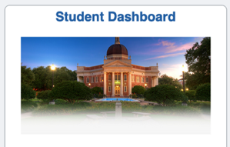

Scroll down the page and click the Academics menu and select the Application for Degree – Undergraduate option.
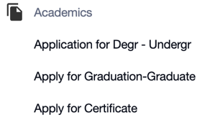
Read the instructions at the top of the screen and then select your Acad Plan and Expected Graduation Term from the drop-down menu and click Submit.
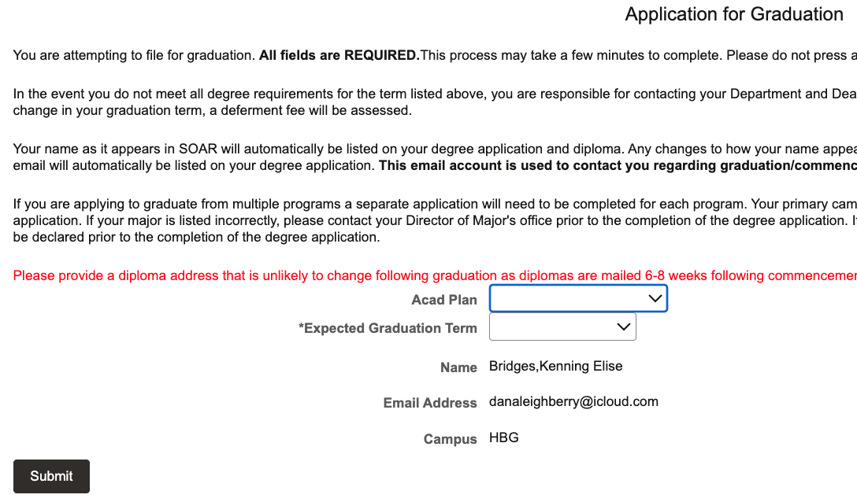
Input the prompted information and click the Pay Application Fee link where you’ll be directed to the CashNet site.

NOTE: turn off pop-up blockers!!
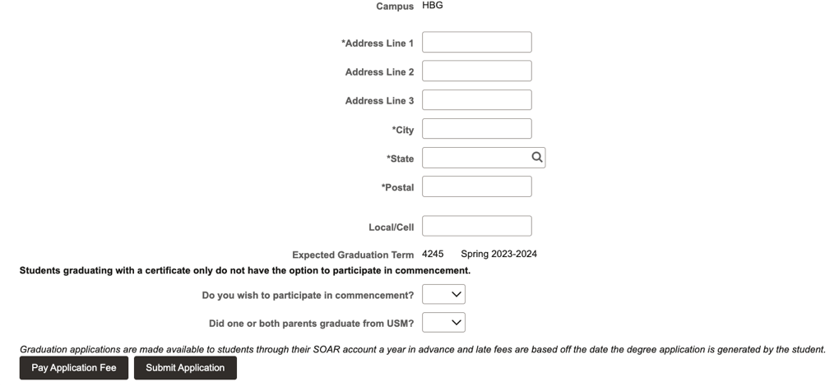
The payment amount will auto generate based on the deadline date for the semester. Input your MasterCard or Visa information and click Continue.
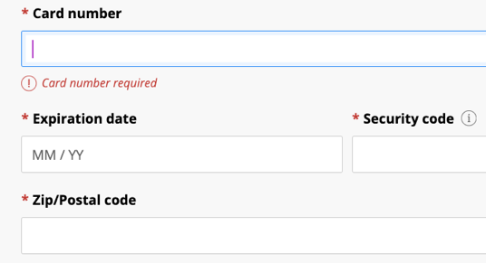

On the next page, input an email address for payment confirmation to be sent and click Pay.

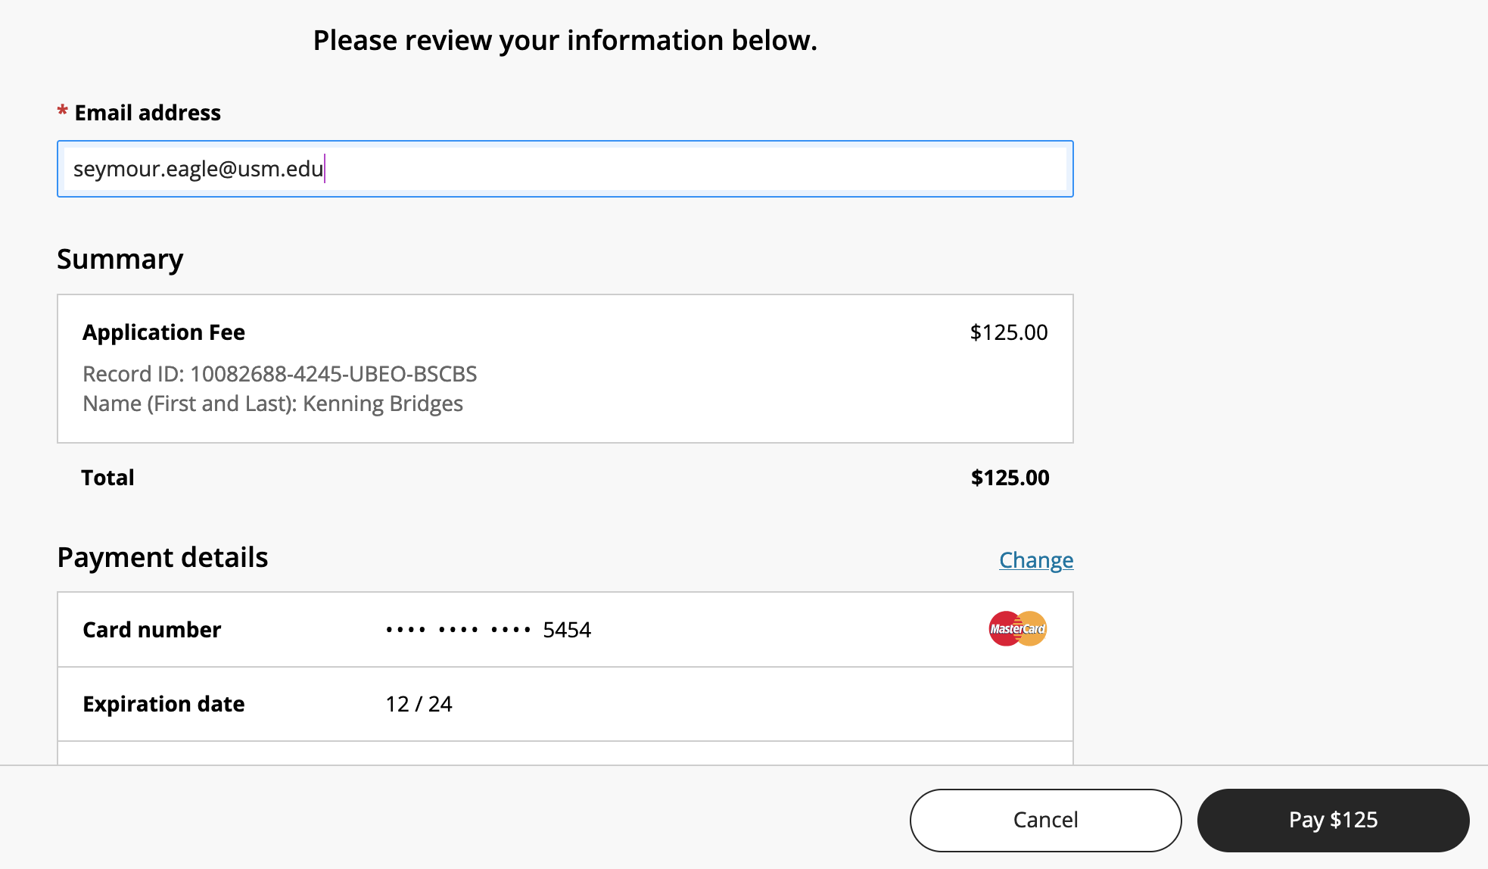
A confirmation will display. Click the Exit button to the payment window.

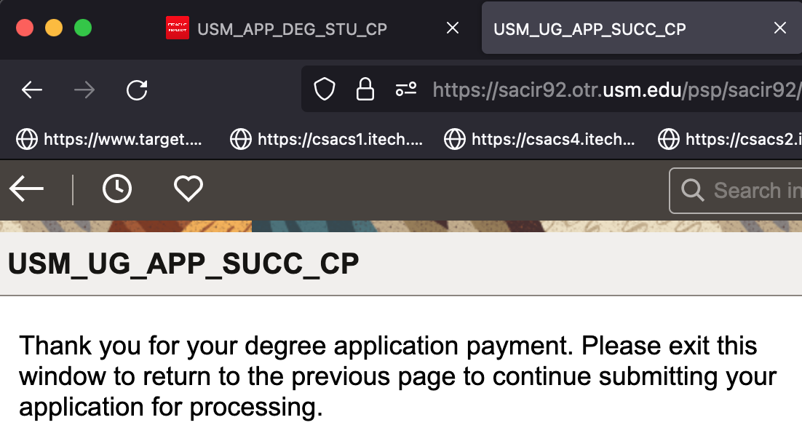
The open window should still display your diploma mailing address in SOAR. Click the Submit Application link to officially submit your degree application with payment.
NOTE: Degree applications will not be accepted without payment.

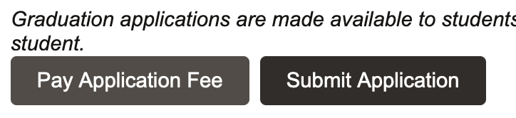
A confirmation email will be sent to your Southern Miss account denoting the successful submission of your degree application.
A second confirmation email will be sent once your degree application has been reviewed and approved by all signature authorities.

