Uploading Revisions to Aquila
To submit a revised document:
  - Login to your Aquila account and click on the title of the submission
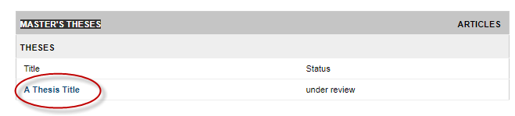

  - In the navigation bar on the left-hand side, click “Revise thesis,” “Revise dissertation,” or “Revise project.” The option selected will be based on the document type.
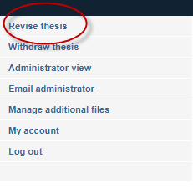
  - The submission form that was completed upon the first submission will appear. Scroll down to “Upload Full Text” on this page and upload the revised document. 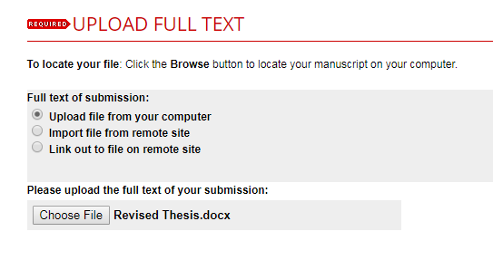
  - Click “submit.” Allow the submission to process before closing out the window.
  - Contact the Documents Specialist to confirm submission of the thesis, dissertation, or doctoral project.
Note: The revision process might be repeated multiple times. All revisions will need to be completed and document will need to be accepted by the final submission deadline.

