**Hiring Manager**

**Frequently Asked Questions about Cornerstone**

1. **What is Cornerstone?**

Cornerstone is the Applicant Tracking System (ATS), an online job posting system used by the University to post open positions, manage applicants and monitor data on our recruiting efforts that support our Affirmative Action Plan. There is a Cornerstone training video on the HR website under [Cornerstone Hiring Manager Guides](https://www.usm.edu/employment-human-resources/internalportal/employment.php).

1. **What will my username and password be in Cornerstone?**

Your username and password will be the same as your SOAR username and password.

1. **Who will have access to the ATS?**

Current faculty and staff will have access to Cornerstone to request & manage requisitions and apply to internally posted positions. Students and adjunct staff will not be able to access the ATS as employees. They are treated as external users. They can apply for positions using a personal email account to positions posted on [jobs.usm.edu](https://usm.csod.com/ats/careersite/search.aspx?site=1&c=usm).

1. **How do I get to Cornerstone?**

The web link will be added the University HR website under Inside HR > Employment > Applicant Tracking System <https://www.usm.edu/employment-human-resources/internalportal/employment.php>

1. **What information can a candidate see about the status of their application within** **Cornerstone**?

They will see “Closed” if they have a not selected disposition or if they failed the prescreening questions. “In Review” is for all steps prior to a final disposition.

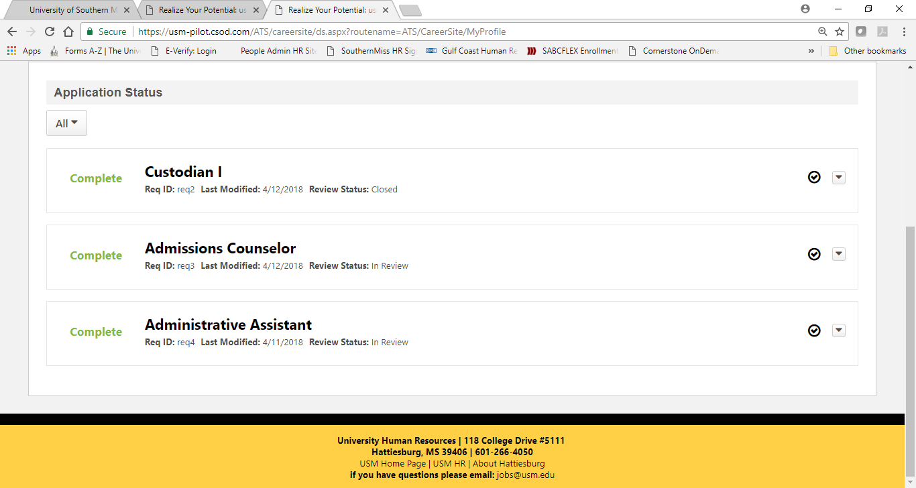

1. **What are font type and size for the job descriptions to match the Job Ad?**

To keep uniformity across all job postings please use **Segoe UI** and **size 3** for the text of a job description within your requisition request.

1. **Will candidates get confirmation that they are no longer being considered for the position once we have given them a not selected disposition?**

Yes, once you take action to change the candidate status to “Not Hired” and select the corresponding [disposition](https://www.usm.edu/employment-human-resources/final_disposition_explanations_nothired.pdf) the candidate will receive an email thanking them for their interest but they are no longer being considered for the position.

1. **Can I post a position for internal applicants only?**

Yes, you will be asked to indicate the posting audience within your requisition request, there you can select Internal or External. Regardless of the posting audience the job description should be pasted into the External Job Description Tab.

1. **Can I post the salary range for the position I am posting?**

Yes, the decision to display the salary range in the job ad is at the discretion of the department and hiring manager. Indicate your preference on the general tab of the requisition request for your HR Partner.

Additional Resources:

[Staff Hiring Toolkit](https://www.usm.edu/employment-human-resources/internalportal/interportal_files/hiring_toolkit_10_21_20.pdf) covers both process and considerations while making hiring decisions.

[Cornerstone Hiring Manager Guides](https://www.usm.edu/employment-human-resources/internalportal/employment.php) cover steps and navigation for the ATS.