**Forbes Best-In-State Employers 2023 Award Logo**

Use of this logo is available to all USM employees so long as used in the following manner per our licensing agreement.

Permitted uses of logo:

- USM websites

- Print and digital signage

- Official documents

- E-mail signatures

Non-permitted uses of logo:

- Social media

- Search engine marketing

- Recruitment websites (non-Cornerstone job ads)

- Paid advertising

*\* Note: The licensing agreement refers only to the use of the official logo; you may share the story that we ranked on the Forbes list in any avenue you wish.*

(Square-White)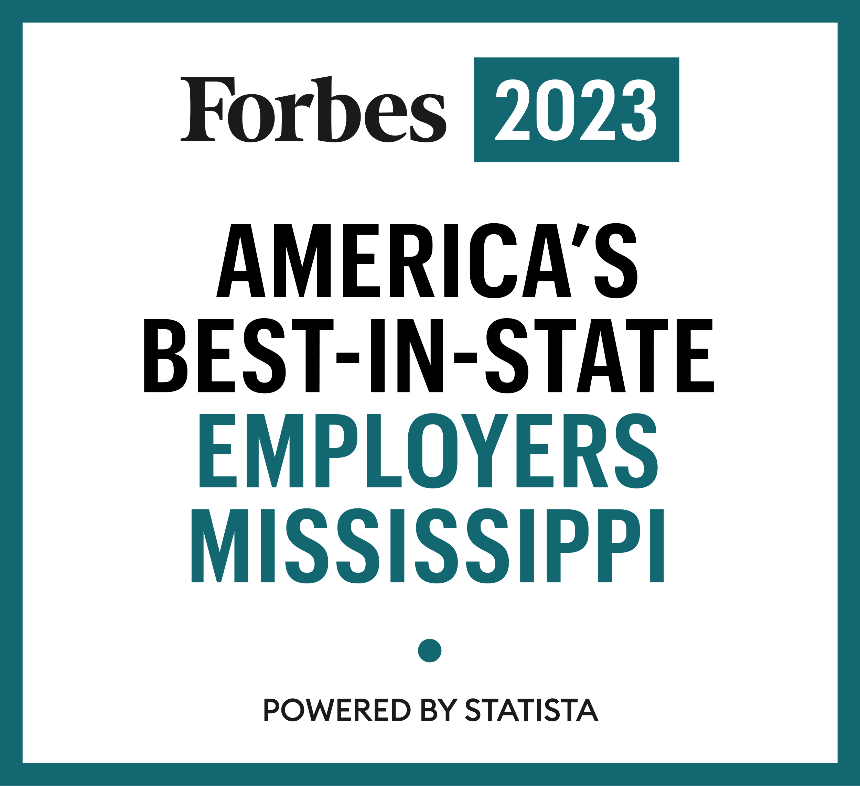

(Square-Dark)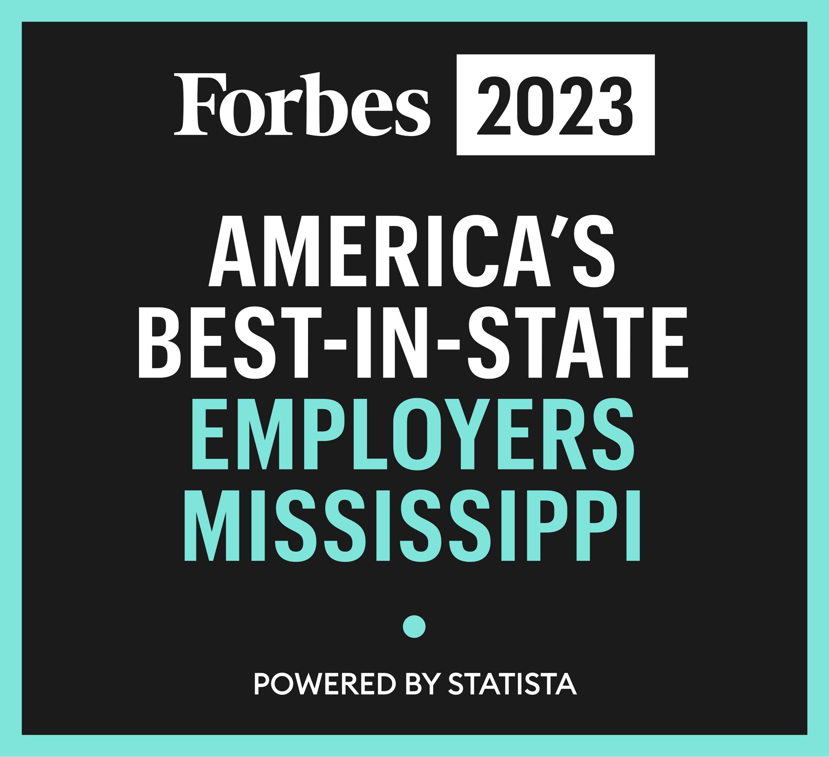

(Square-Color)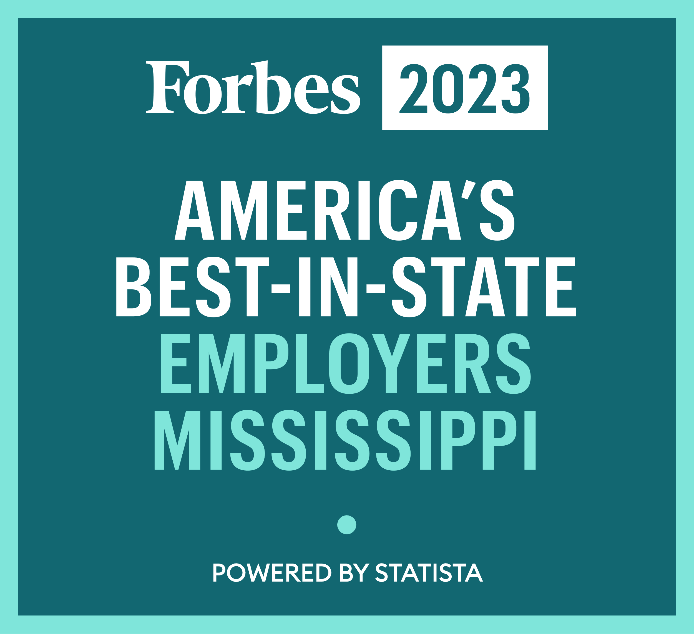

**How To:** [Add a signature](https://support.microsoft.com/en-us/office/create-and-add-an-email-signature-in-outlook-5ff9dcfd-d3f1-447b-b2e9-39f91b074ea3) in Office 365

**How To**: [Add a signature](https://support.microsoft.com/en-us/office/create-and-add-a-signature-to-messages-8ee5d4f4-68fd-464a-a1c1-0e1c80bb27f2) in Outlook

**How To:** [Add a signature](https://support.microsoft.com/en-us/office/create-and-insert-a-signature-in-outlook-for-mac-f4d21492-0956-4429-95ad-2769745b539c) in Outlook for Mac

For questions or clarification on uses of the logo, contact your HR Partner, Miranda Brumfield, at 6-5814 or Miranda.Newman@usm.edu.