Cornerstone Requisition Requests Steps

**Step 1:** From Login screen hover over Recruit and select Requisition Request

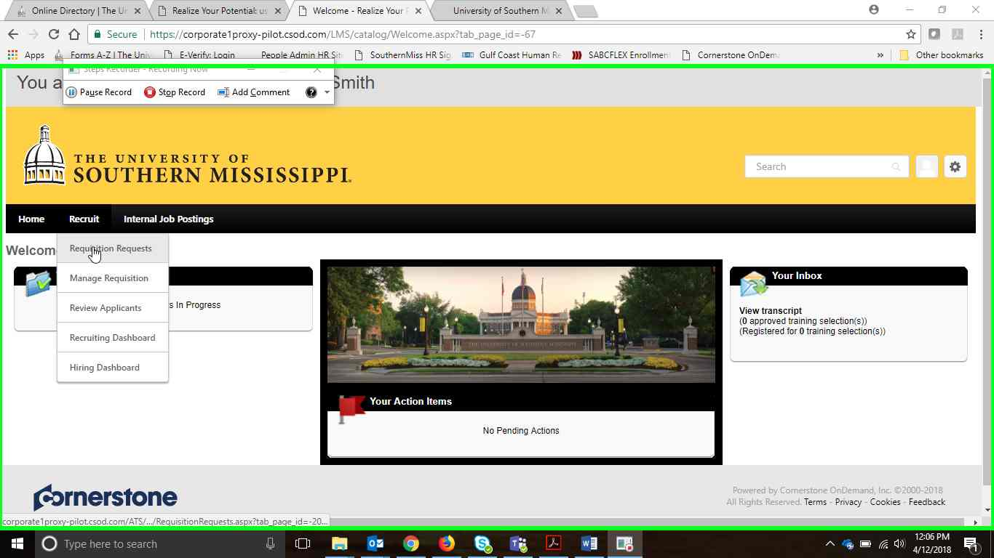

**Step 2:** From Requisition Request you can “+ Create New Request” or “copy” a previous request.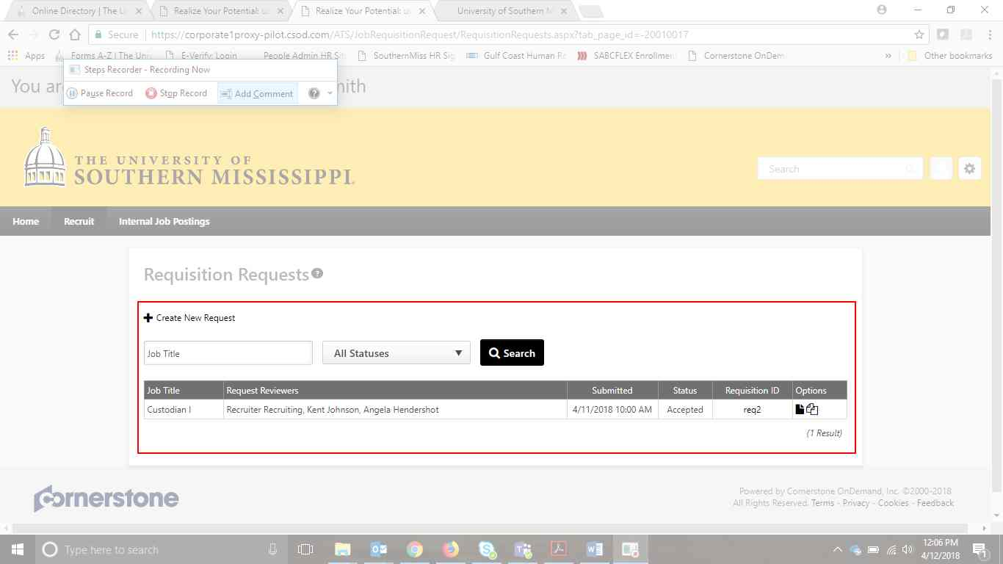

**Step 3:** Here we will Create New Request

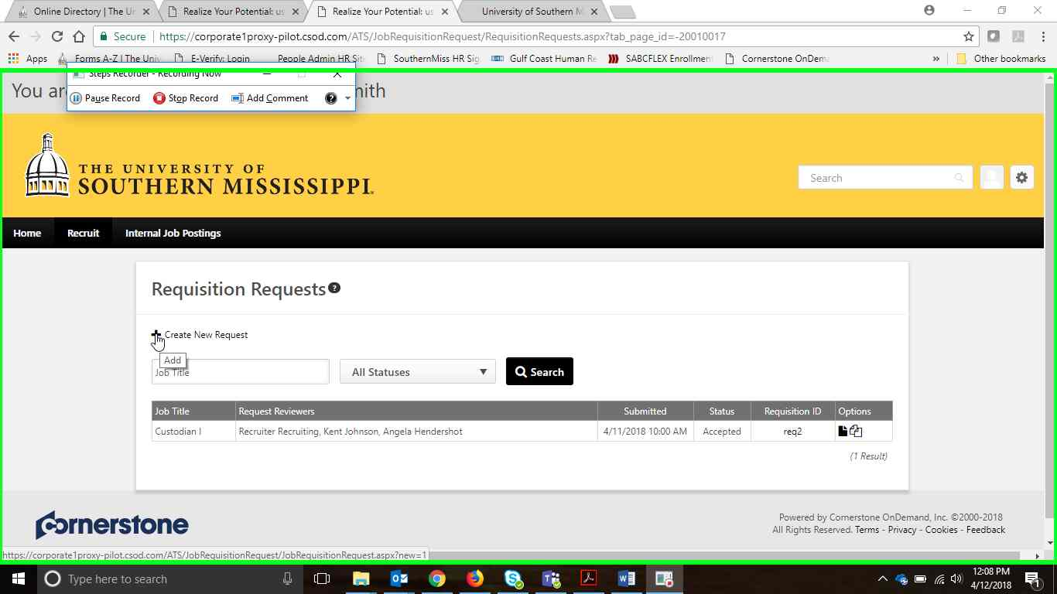

**Step 4:** Create Requisition Request page appears. Click on the notepad next to “Position” to select job title.

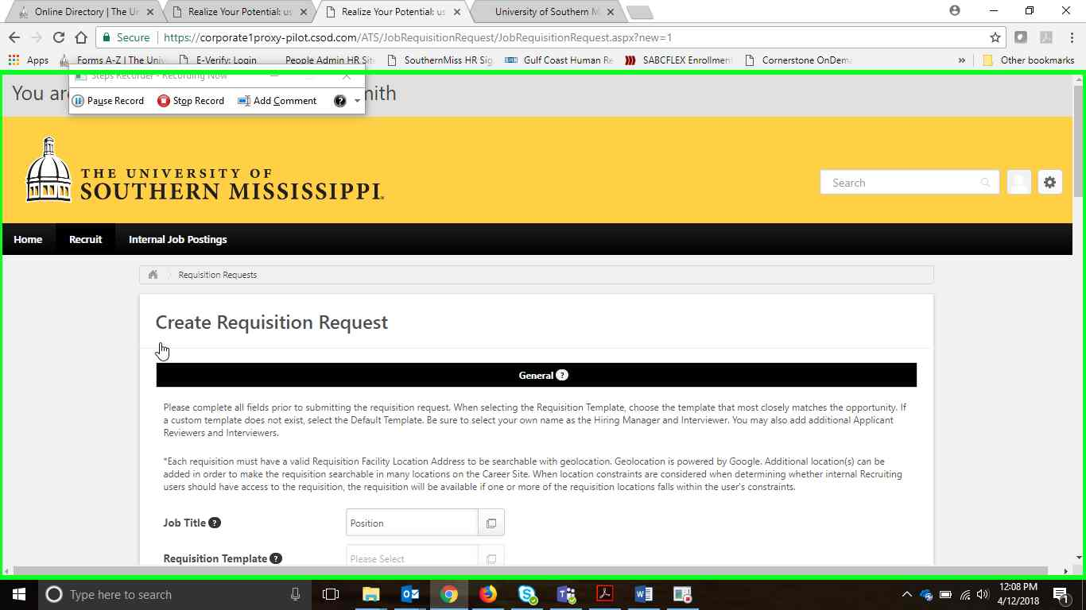

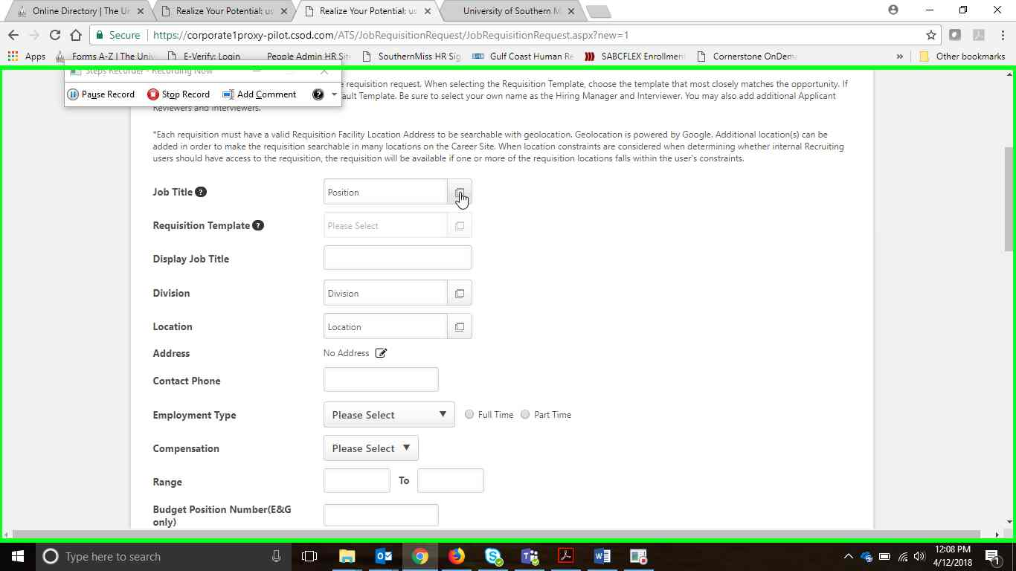

**Step 5:** Search for desired position title from list provided. You will be able to adjust the “Display Title” in the Requisition Request. If the desired title is not found in the position directory contact your HR Partner.

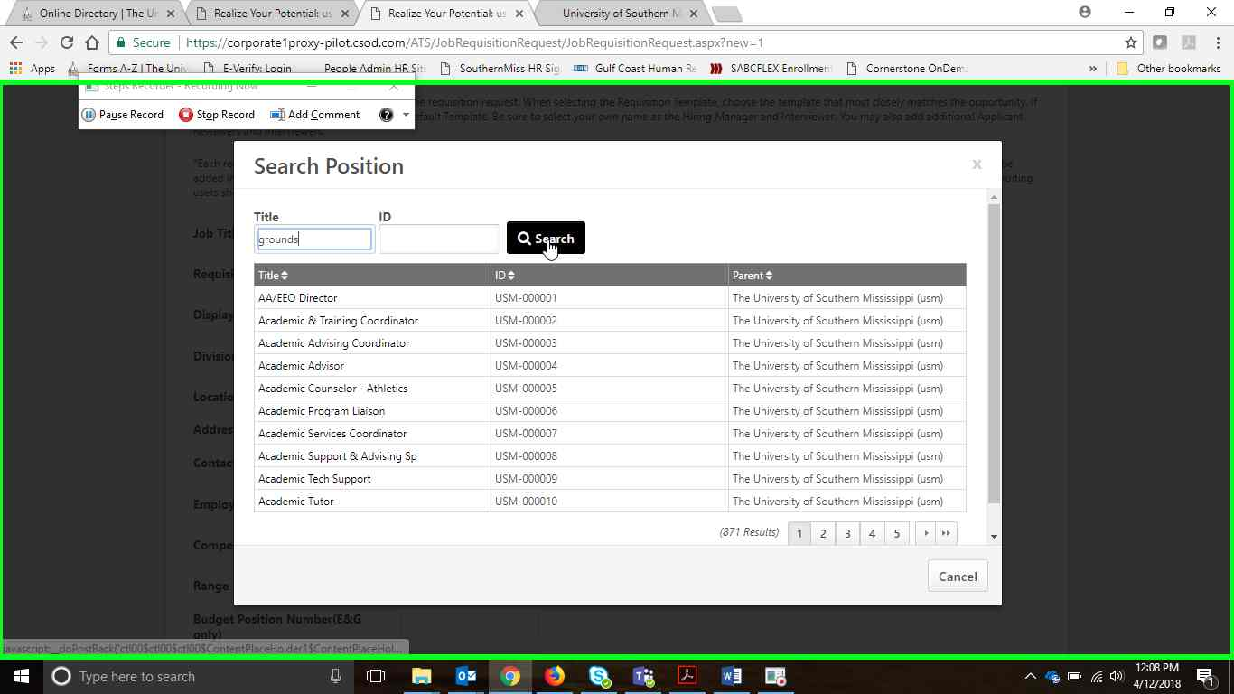

**Step 6:** Click to select desired position title.

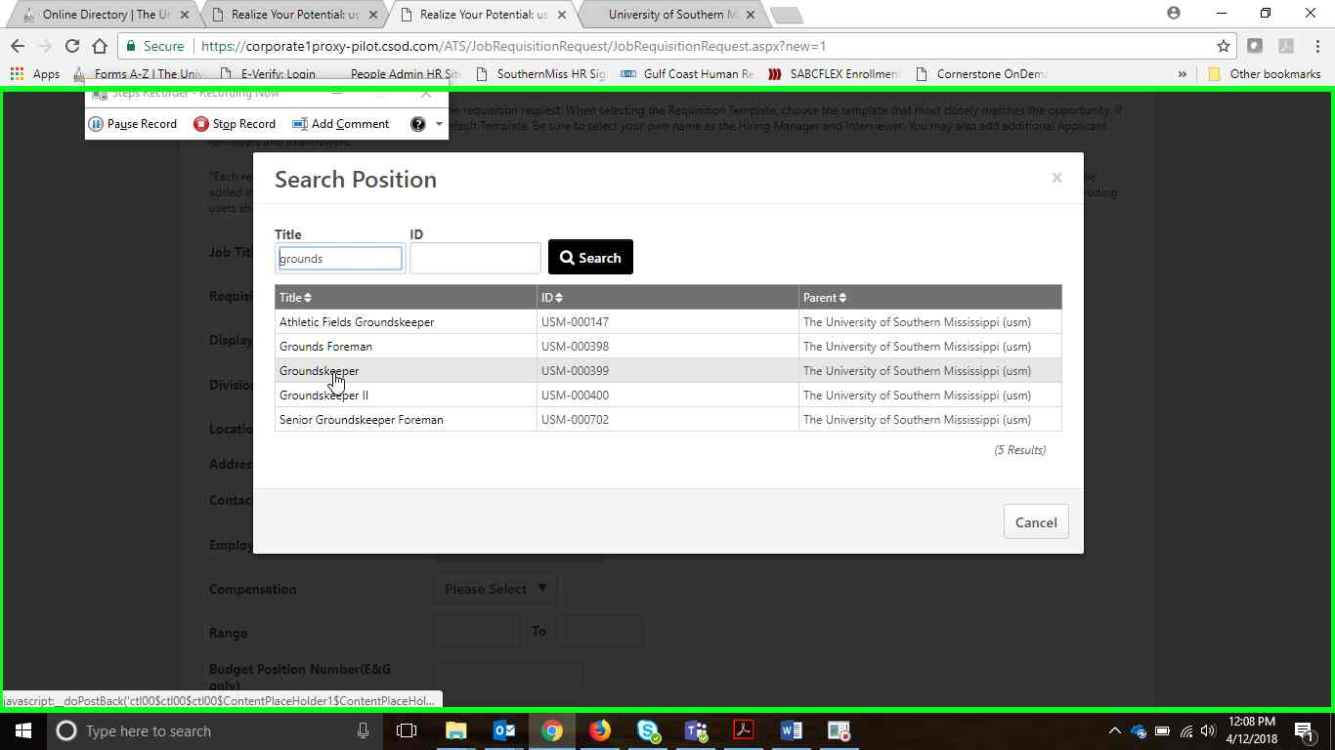

**Step 7:** You should see “Default Requisition Template” populate so that your job description headings populate below. Add Requisition Details to the page. Please note that regardless of your posting audience, you should always paste your job description onto the “External Tab”. Your HR Partner will post the job to the internal or external website at your request. The Internal tab should always be set to “Clone External Description”. 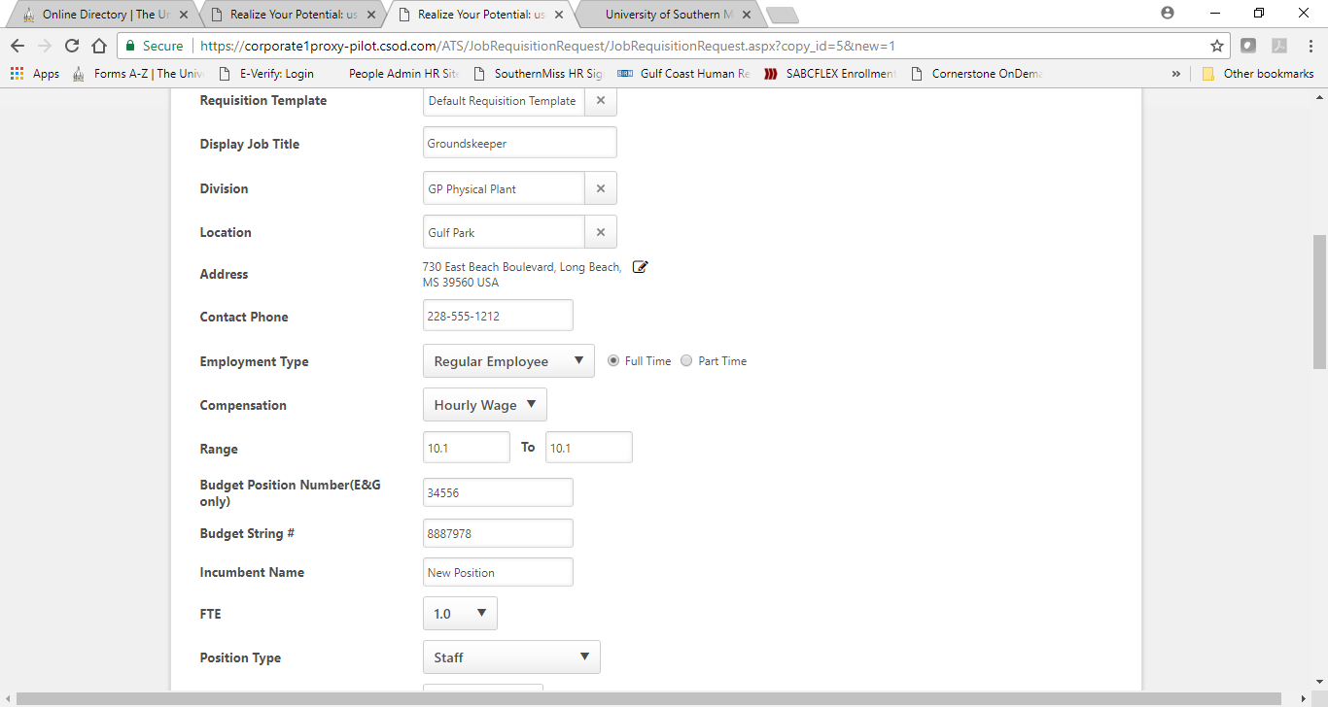

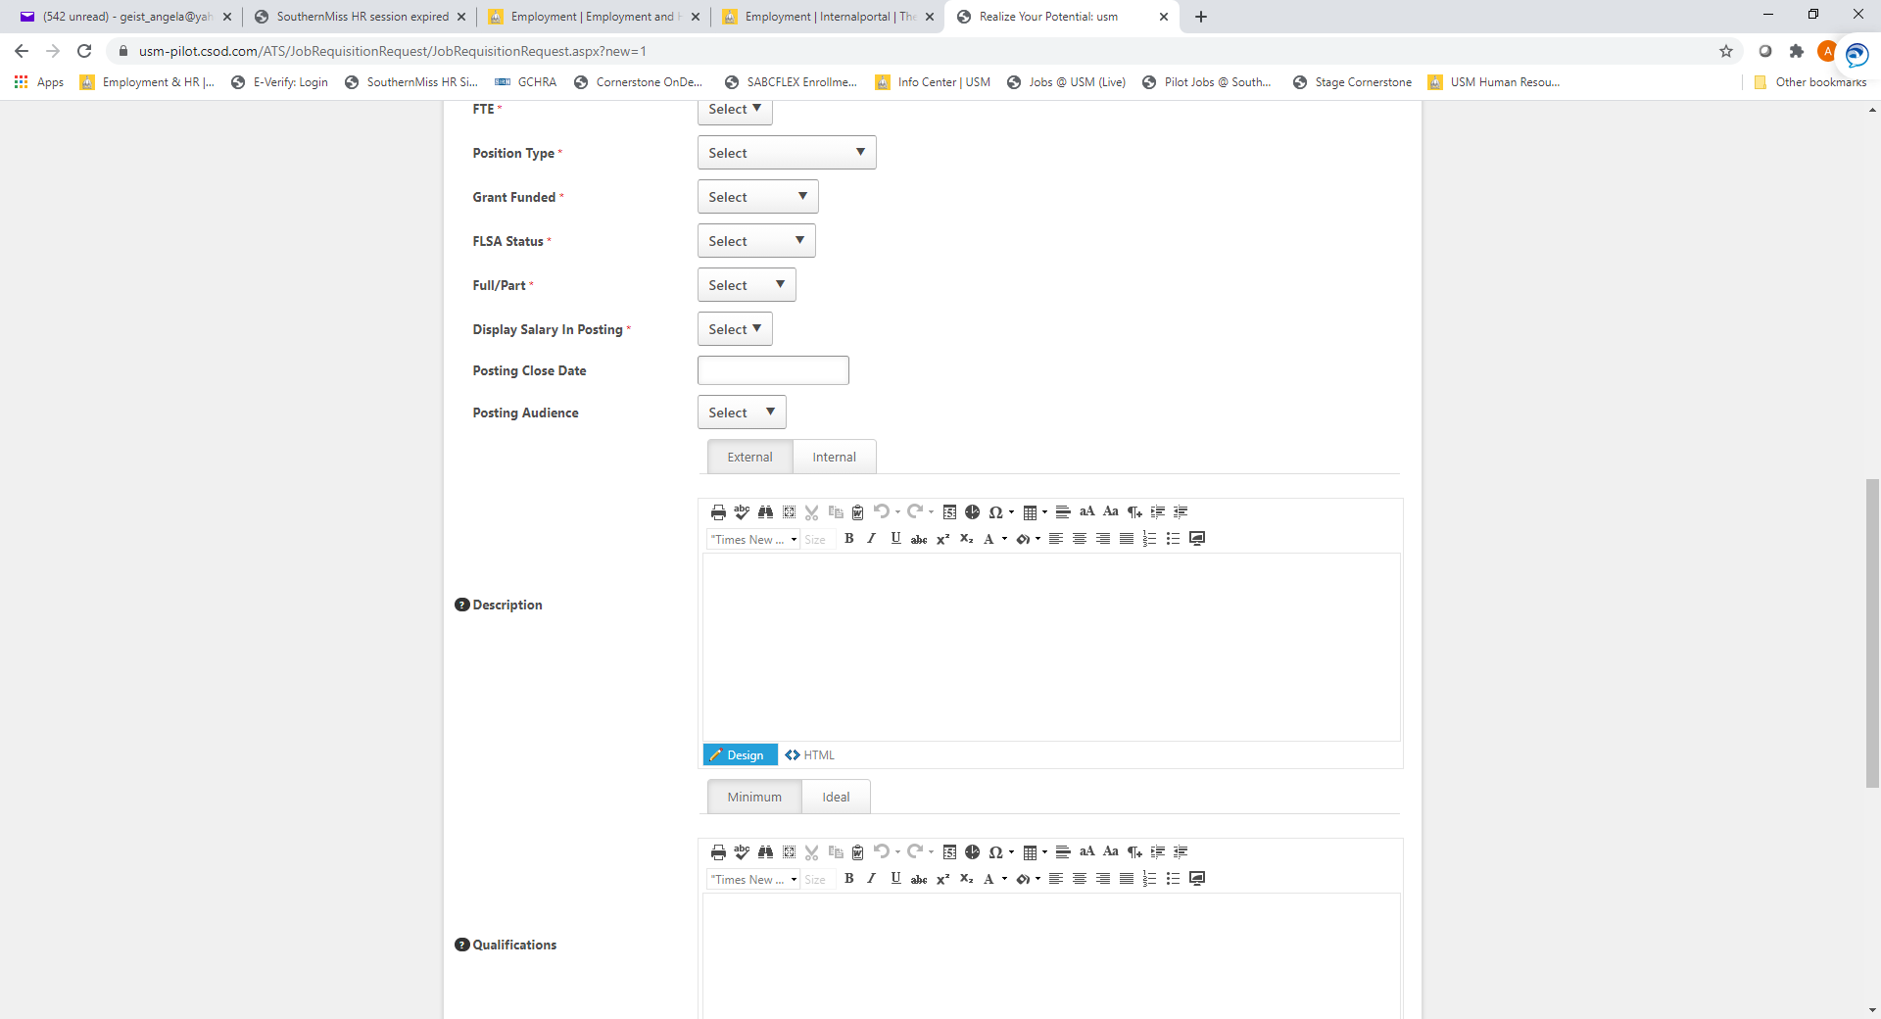

**Step 8:** In the “Default Requisition Template” you will need to add the specific position description for this job requisition and posting. The shell or layout is provided to keep a standard format for all University job postings. Use Font Name **Segoe UI** and **size 3** to make text uniform. Click the icon “Paste from Word” to strip the formatting from your job description and paste under each heading – Job Summary, Primary Duties & Responsibilities in the Description box, and Minimum Qualifications and Preferred Qualifications in the Qualifications box. Please leave these headings as they are (Preferred Qualifications can be removed if not applicable). This information will be joined with other position details when the Requisition is posted. Use the heading “Special Instructions to Applicant” to highlight important details to applicants such as scheduled hours or additional attachments to include with application. This heading is not required.

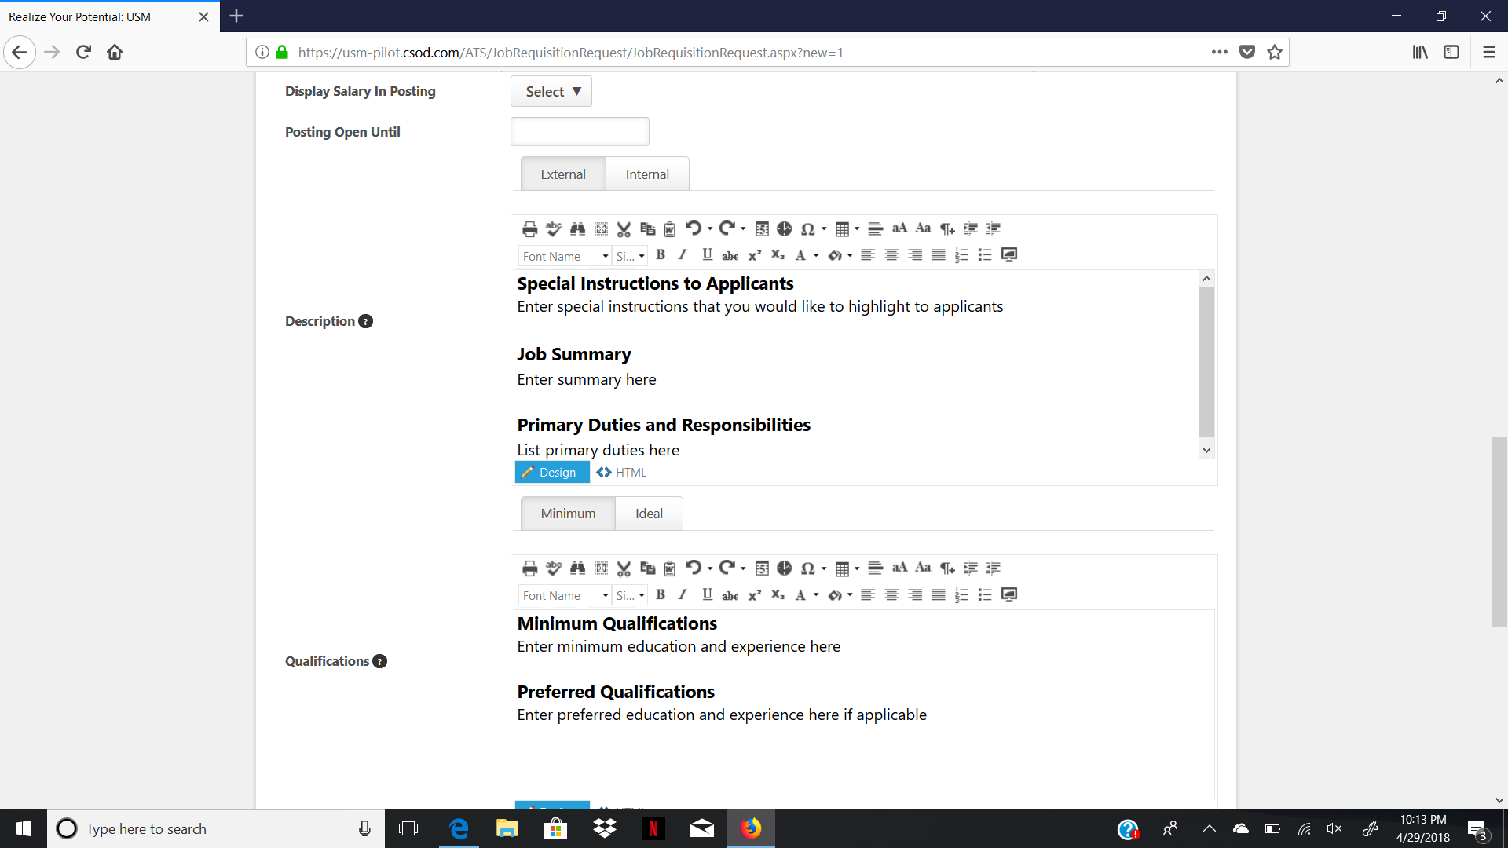

**Step 9:** Add Hiring Manager & Reviewers that need to have access to move candidates through the requisition/hiring process. Please note that if your committee members need to participate in the candidate review they will also need to be added here as Reviewers.

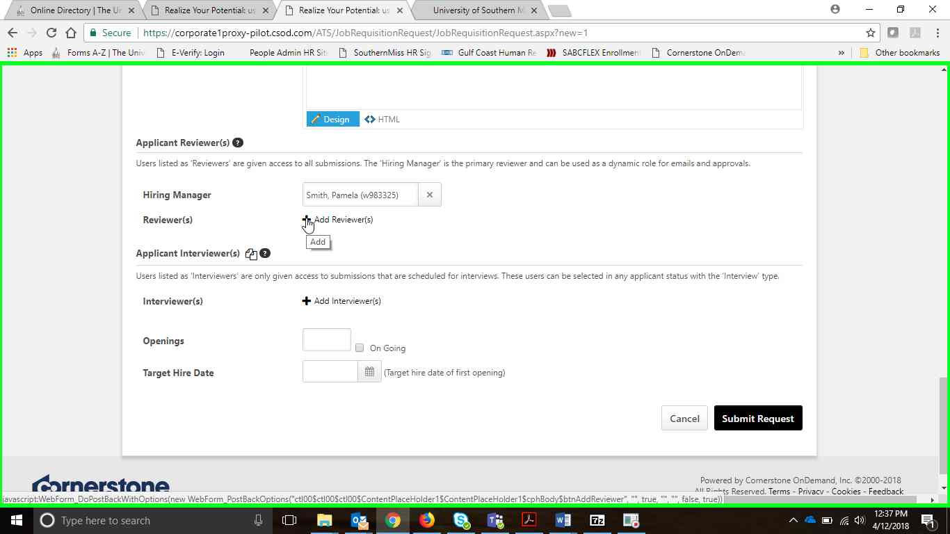

**Step 10:** Add # of openings, target hire date and then submit request.