**Applicant - Frequently Asked Questions**

1. **How do I apply for jobs at USM?**

Applicants can see and apply for available jobs at The University of Southern Mississippi through our employment links on [jobs.usm.edu](https://jobs.usm.edu/).

1. **How do I reset my password?**

If your applicant account is associated with a personal email address you must use the “forgot password” feature within the Applicant Tracking System (ATS). If your account is accessed using the single sign-on feature and your soar credentials, you must reset your soar password through iTech. (See Also FAQ 6 below)

1. **What information do I needed to apply for positions at USM?**

Our new applicant tracking system uses “Resume Parsing” to generate an Employment Application. Generally, applicants will be required to upload a resume in PDF or Word (preferably in a scannable format) and a cover letter, as well as provide contact information for three professional/educational references. Some positions may also have special instructions, which are the responsibility of the applicant to follow.  ***Applicants should also be prepared to upload all documents identified in the job posting or desired by the applicant during the first step in the application process as you will not be able to add additional files to your application after moving on to the next step.*** Files can be changed for subsequent applications as each are independent submissions in Cornerstone.

1. **I have just submitted my application. Do I need to create a candidate profile?**

Yes, it is recommended that you create an applicant profile after submitting your application to ensure that you receive up to date communication about your application from our ATS. You will need a profile if you are selected for any position within The University of Southern Mississippi to complete the hiring process.

1. **Can I withdraw my application and then resubmit with new documents?**

Yes, although we recommend that you prepare all requested documents in a job ad prior to beginning the application process.

1. **I am getting an error message when using my @usm.edu email address that says my email address is not available what should I do?**

If you are a current faculty or staff member please apply for the position through the Internal Career Center link using your soar credentials. If you are not a current faculty or staff member (adjunct faculty will also need to use a personal account) please use a personal email account such as yahoo, hotmail, gmail, etc.

1. **Will I get any notification if I am no longer being considered for a position?**

Yes, you will receive an email through our applicant tracking system with your status for a position once a decision about your application is made. You can also log into the portal to check your application status. Unfortunately, University Human Resources cannot provide personal status updates due to the number of applicants we receive for our positions.

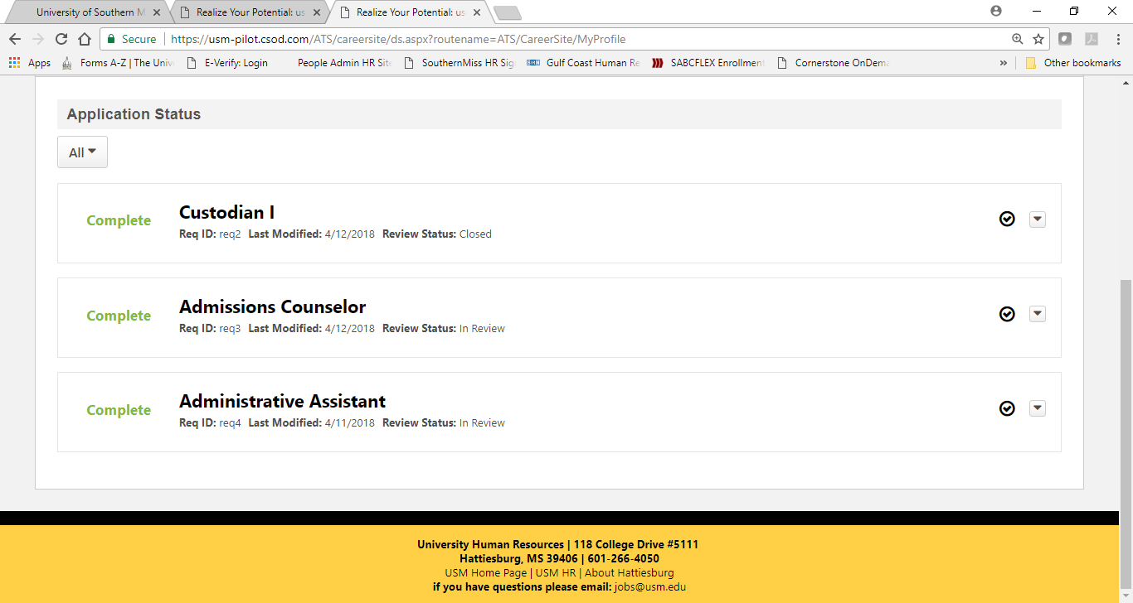

1. **The job I am applying for does not show the salary range, where can I find that information?**

Displaying the salary range for a position is at the discretion of the hiring manager. If it is not displayed then that information would be discussed at the time of interviews.

1. **Can I be notified when new positions become available?**

Yes, you can create “Job Alerts” based on your search criteria of Keyword, Location or Position type from Cornerstone by clicking on “Create Job Alert” under the keyword search box.

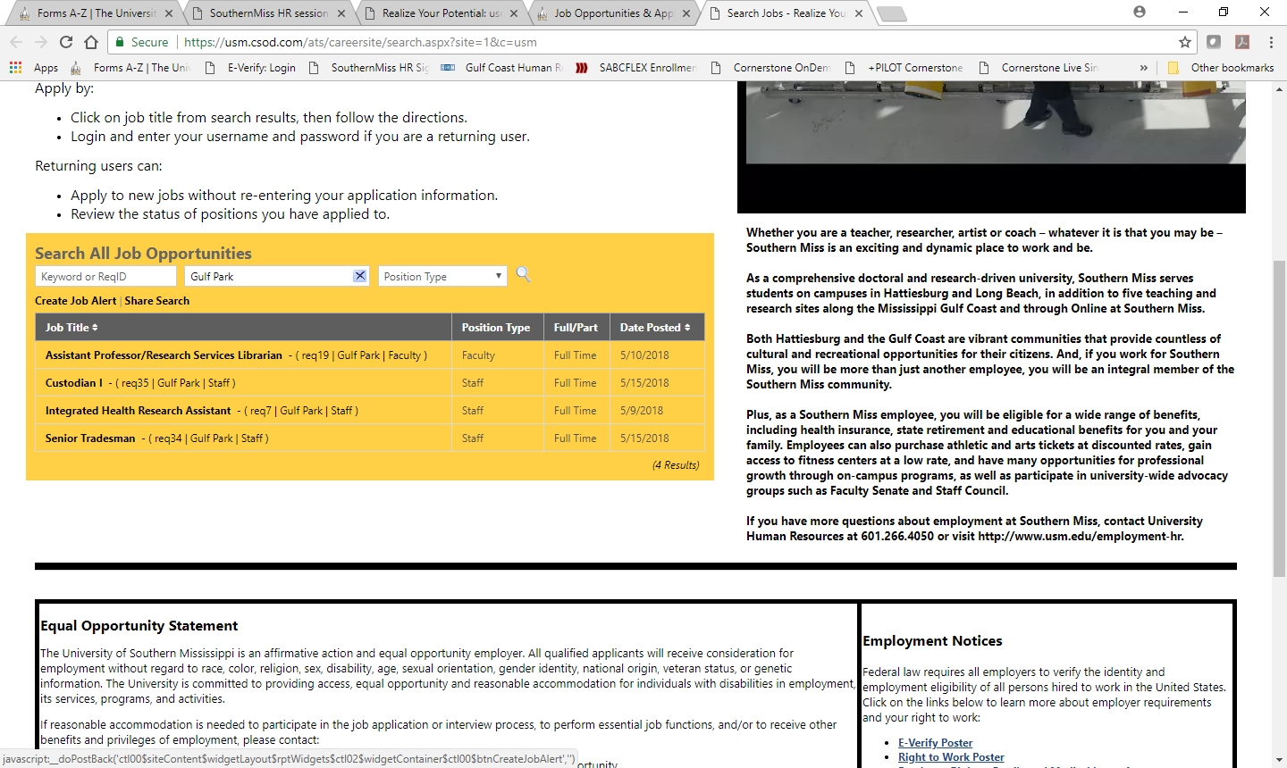

1. **I was offered a position and told to go online to accept the offer, where do I do that?**

To accept an offer, log into your candidate profile and view your pending tasks <https://usm.csod.com/ats/careersite/search.aspx?site=1&c=usm> The task bar has All, Pending, or Completed as filter options.

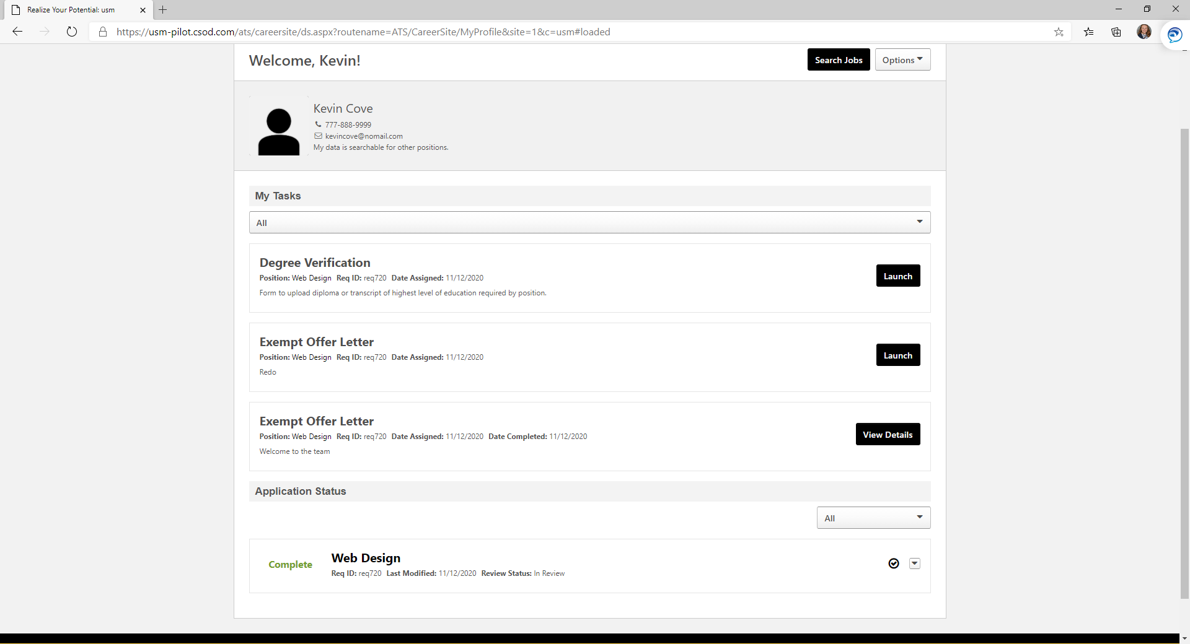

1. **After initiating the background check I was told to Log into my profile again and complete an onboarding form, how do I do that?**

You will use a separate link to log in for the onboarding form than the offer letter, degree verification, and the faculty recommendation letter process. Log into your profile using this link: <https://usm.csod.com/client/Usm/default.aspx>? The onboarding form will be in the bottom right under Your Action Items.

