Class Schedule Guide Instructions
How to run the Open/Closed Class report

- Set up/Use run control
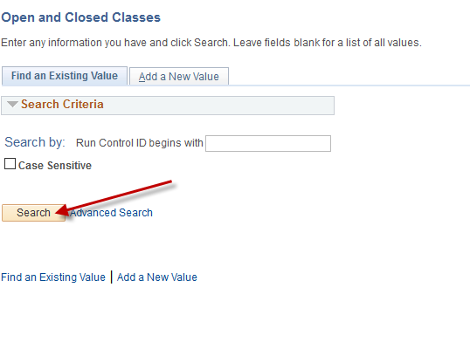

- Enter Academic Organization (if you wish to only view your classes) – leave blank if you wish to view all classes; Session should be Regular; Term for Spring 2020 is 4205. Campus selection – check all boxes. Open and Closed Selection – choose Both. Click Run.
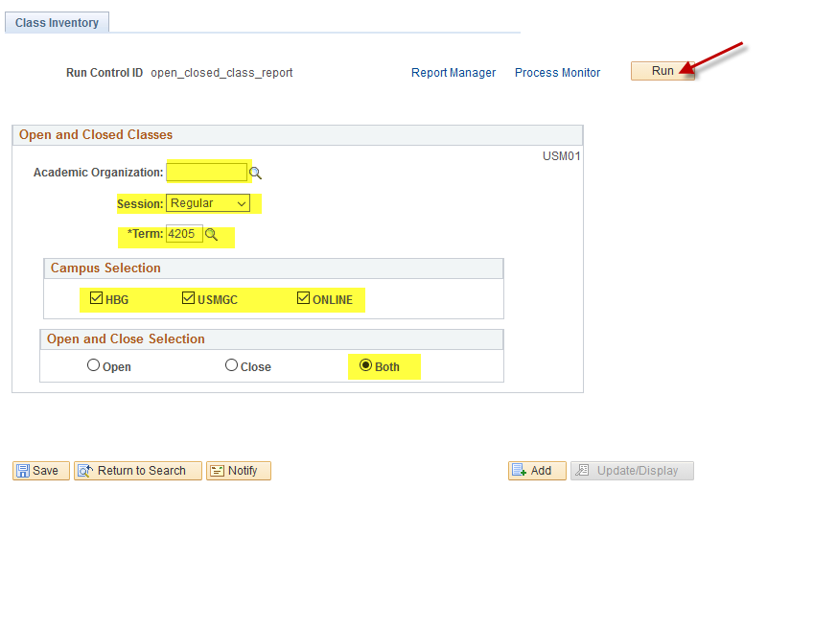
- Server Name should be PSUNX; Type should be Web; Format should be PDF. Make sure the box is checked. Click Ok.
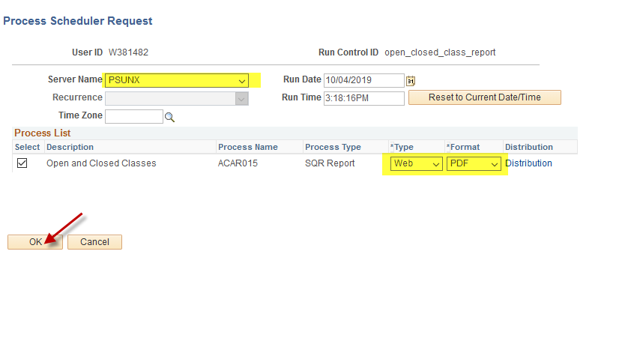
- Click Process Monitor; Refresh until Run Status reads Success – Posted. Click Details.
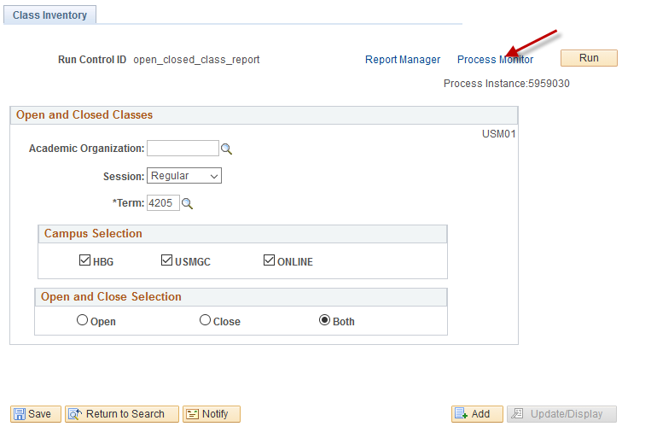
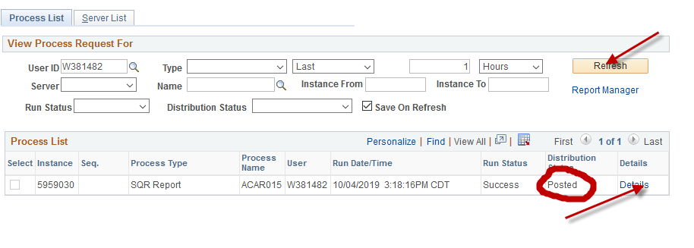

- Click View Log Trace.
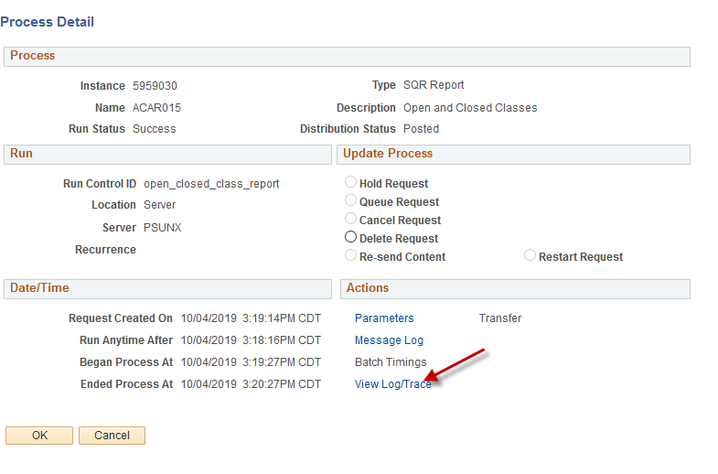
- Select the pdf file.
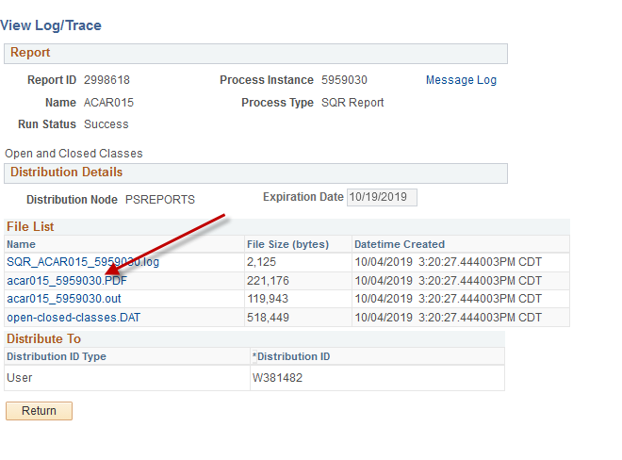
- Print or save document. This information changes daily.

